**Best Uses:**

* Philips curve Long run shows no relationship in the long run between the price level and unemployment
* Highlights the concept of natural unemployment and the risk of reducing this rate of unemployment is inflation in the long run.
* This highlights the limitations facing government to reduce unemployment in the long run using expansionary fiscal policy.
* Counterproposal from the monetarists was government policies to promote supply side growth

ED 17: Long run Philips courve

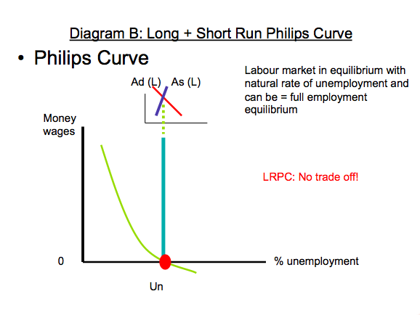

**SL+HL:**

1. Trade off: policies used by government will lead to a ‘trade off’ between unemployment + inflation ie more jobs with more inflation

**For HL:**

1. Note the connection between the AS/AD and the Philips Curve. Attempts to reduce the natural unemployment rate with lead to more inflation. This is likely to be deman- pull inflation. This is likely to be followed by cost-push inflation as workers look for higher wages. Economy will only move away from U**n** temporarily and the economy according to the monetarists will return to Un in the Long Run