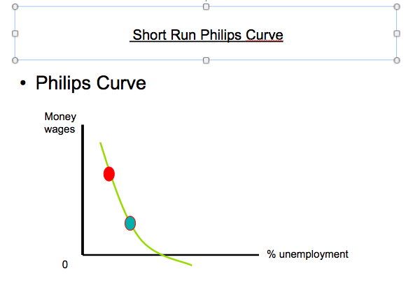

**SL+HL:**

1. Trade off: policies used by government will lead to a ‘trade off’ between unemployment + inflation ie more jobs with more inflation.

**For HL:**

1. Note the connection between the AS/AD and the Philips Curve. Attempts to reduce the natural unemployment rate with lead to more inflation. This is likely to be demand- pull inflation. This is likely to be followed by cost-push inflation as workers look for higher wages. Economy will only move away from U**n** temporarily and the economy according to the monetarists will return to Un in the Long Run

ED 11: Philips Curve curve

**Best Uses:**

* Philips curve (short run) shows the “trade off” policy makers face in using monetary + fiscal policies to manage an economy: growth with inflation or contraction with lower inflation (disinflation). Injecting an economy has risks. Use with AS/AD.