ED 4: AS/AD
Best Uses:
- inflation above yfe (full employment equilibrium)
- unemployment below yfe
- short and long run equilibrium for a macreconomy

Essential diagrams:

Some key points worth noting:

- Full employment equilibrium occurs at Y1 where the economy is operating in the short run at its long run capacity. This is optimal. However remember that Y1 includes natural unemployment ( seasonal, frictional and structural)
- Y3 is a situation whereby there is a inflationary gap. See Yellow/ dotted area. Here the economy is operating above long run capacity. This level of output is not possible in the long run.
- Y2 is a recessionary gap. See pink boxed area. Here the short run equilibrium is clearly below what the country is capable of producing. (For a fuller explanation see Blink+Dorton)

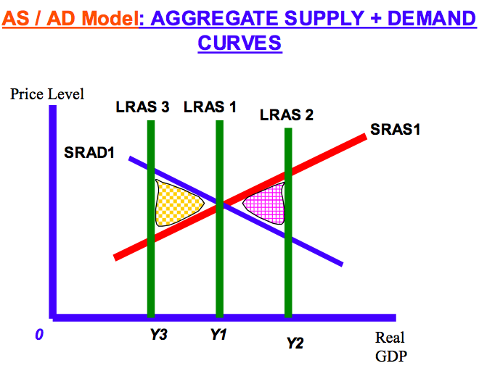
AD: influence that cause a movement:

Change in price level

AS: influence that cause a movement:

Chang in Price Level

AD: influences that shift
- Fiscal
- Monetary
- Foreign income changes
- Expectations
- External shock
AS: influences that shift
- Quantity and quality of FoP

Please note that it is always better to label the X axis with “Real GDP”.

Useful for any discussion of macroeconomic policy including inflation and unemployment
Useful for essays on Development
Essential for essays on unemployment and inflation

