**4.1 Economic Development**

1. **economic growth**
2. **economic development**
3. **physical capital**
4. **human capital**
5. **poverty**
6. **poverty cycle (+ diagram)**
7. **international development goals**
8. **millennium development goals**
9. **resource endowment**

**ED 23**

**8 themes in development:**

1. **development + growth**
2. **measuring development**
3. **domestic factors ( eg micro credit scheme)**
4. **international trade**
5. **FDI**
6. **Aid**
7. **indebtedness**
8. **aid or trade?**

**Poverty Cycle/Poverty Trap**

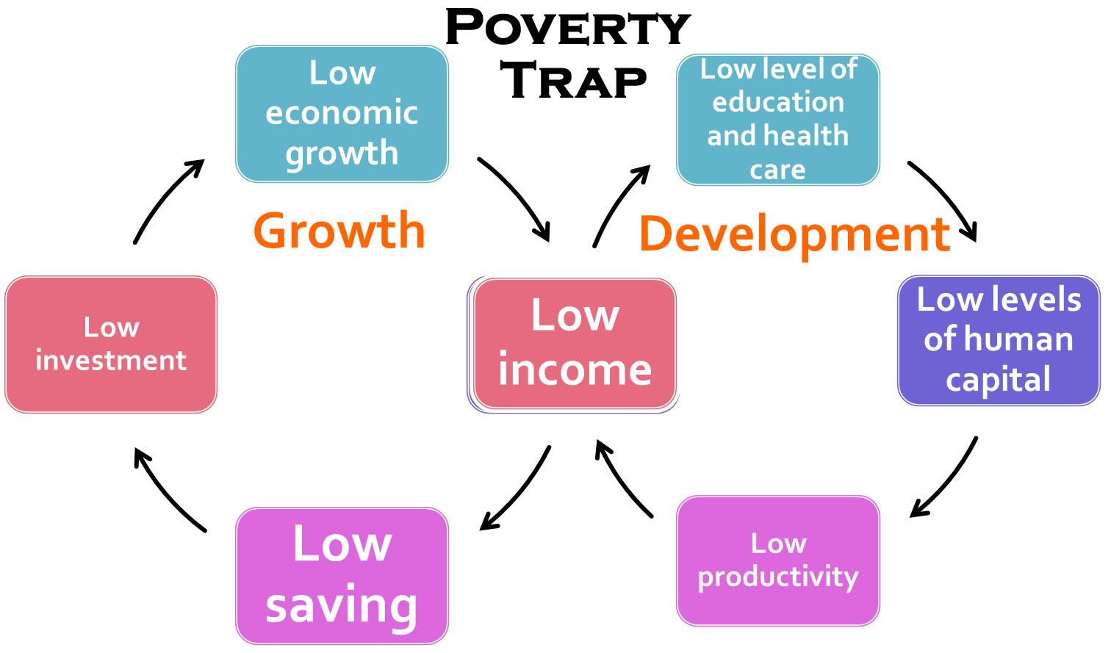

Note: Blink shows these cycles moving in opposite directions with the development cycle moving anti clockwise. Probably just as effective to show them as above moving clockwise!

Millenium Development Goals

**ED 23**

Source: http://www.unmillenniumproject.org/goals/index.htm

|  |
| --- |
|  |
| |  |  | | --- | --- | | [mdg1](http://www.unmillenniumproject.org/goals/gti.htm%23goal1) | [**Goal 1: Eradicate Extreme Hunger and Poverty**](http://www.unmillenniumproject.org/goals/gti.htm#goal1) | | [mdg2](http://www.unmillenniumproject.org/goals/gti.htm%23goal2) | [**Goal 2: Achieve Universal Primary Education**](http://www.unmillenniumproject.org/goals/gti.htm#goal2) | | [mdg3](http://www.unmillenniumproject.org/goals/gti.htm%23goal3) | [**Goal 3: Promote Gender Equality and Empower Women**](http://www.unmillenniumproject.org/goals/gti.htm#goal3) | | [mdg4](http://www.unmillenniumproject.org/goals/gti.htm%23goal4) | [**Goal 4: Reduce Child Mortality**](http://www.unmillenniumproject.org/goals/gti.htm#goal4) | | [mdg5](http://www.unmillenniumproject.org/goals/gti.htm%23goal5) | [**Goal 5: Improve Maternal Health**](http://www.unmillenniumproject.org/goals/gti.htm#goal5) | | [mdg6](http://www.unmillenniumproject.org/goals/gti.htm%23goal6) | [**Goal 6: Combat HIV/AIDS, Malaria and other diseases**](http://www.unmillenniumproject.org/goals/gti.htm#goal6) | | [mdg7](http://www.unmillenniumproject.org/goals/gti.htm%23goal7) | [**Goal 7: Ensure Environmental Sustainability**](http://www.unmillenniumproject.org/goals/gti.htm#goal7) | | [mdg8](http://www.unmillenniumproject.org/goals/gti.htm%23goal8) | [**Goal 8: Develop a Global Partnership for Development**](http://www.unmillenniumproject.org/goals/gti.htm#goal8) | |

Gender Gap Report: Income, social participation, health, political inclusion and economic participation.

http://reports.weforum.org/global-gender-gap-report-2014/rankings/