Dictionary
Item Number | Term | Definition | Diagram/Example
1 | Economics | A social science that analyzes the production, distribution and consumption of goods and services  A study of how the society allocates its resources of the factors of production.
2 | Social Science | Field of study concerned with society and human behaviours | Branches: Economics, History, Anthropology, Archaeology
3 | Microeconomics | Branch of Economics that analyzes the market behavior of individual consumers and firms  Studies the behavior of individual households and firms in making decisions on allocation of limited resources | Eg: Coffee Industry  How the change in the price of a good affects a family’s purchasing decisions
4 | Macroeconomics | Branch of economics concerned with economy wide phenomena | Talks about things like inflation, target rate of interest, what influences (un)employment
5 | Economic Growth | Increase in the capacity of an economy to produce goods and services, compared from one period of time to another | 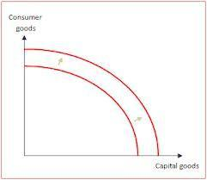  Economy now has more resources, machines and labour to produce MORE. The ability to produce has increased.  Increase in national income, real national income, real national income per capita also mean economic growth
6 | Economic Development | Sustained, concerted effort of policymakers and community to promote the standard of living and economic health | ^^There is development because the ability to produce capital goods has increased.  Eg: development of human capital, standards of living, healthcare, safety, environmental sustainability, literacy
7 | Sustainable Development | Development that meets the needs of the present without compromising the ability of future generations to meet their own needs
8 | Positive Economics | Branch of economics that concerns the description and explanation of economic phenomena | A positive economic theory might describe how money supply growth affects inflation, but it does not provide any instruction on what policy ought to be followed.
9 | Normative Economics | Part of economics that expresses value judgment about economic fairness or what the economy ought to be like or what the goals of public policy ought to be | A normative statement: “The price of milk should be $6 a gallon to give dairy farmers a higher living standard and to save the family farm” – reflects value judgment
10 | Ceteris Paribus | All other things being kept same/equal/constant | On the demand curve, ceteris paribus acts like a pause button. While one factor changes assuming that the others DO NOT change
11 | Scarcity | Something not enough to satisfy ones wants | Everybody wants more than what they have. Resources are scarce. Resources on the earth are less than the size of peoples wants.
12 | Factors of Production | An economic term to describe the inputs that are used in the production of goods or services in the attempt to make an economic profit. | Land, Labour, Capital, Enterprise
13 | Land | Comprises of all naturally occurring resources whose supply is inherently fixed. | Mineral Deposits, geographical locations,
14 | Labour | Human resources. Labour – Workers. Measure of work done by human beings | People running a company
15 | Capital | Already-produced durable goods used in production of goods and services | Machines
16 | Management/Entrepreneurship | The act of being an entrepreneur – one who undertakes innovations, risks, finance and business acumen in an effort to transform innovations into economic goods | Entrepreneur of Apple – Steve Jobs
17 | Factor incomes | Income derived from the selling the services of factors of production. | Labour – Wages  Income from Land - Rents
18 | Choice | Deciding between different uses of scarce resources. Choice relates with Opportunity cost. Example→ | Government has to make a CHOICE between spending more on healthcare or more on housing facilities. It chooses to spend more on health care and thus the opportunity cost of spending more on healthcare is the reduction in the housing facilities.
19 | Utility | Representation of preferences over some set of goods and services. Preferences have a utility representation so long as they are transitive, complete, and continuous. | 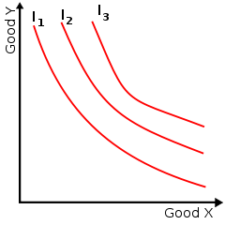  Utility is usually applied by economists in such constructs as the indifference curve, which plot the combination of commodities that an individual or a society would accept to maintain a given level of satisfaction.
20 | Opportunity Cost | The sacrifice made in order to have the next most desired Alternative. | Choosing between going to a rock concert and buying Music CD's.  If you choose going to a rock concert, then  opportunity cost is buying Music CD's  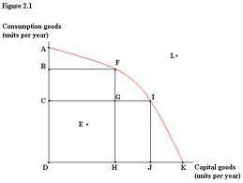  If an economy wanted to get from point “F” to point “I” on the PPF, in other words, it wanted to increase the production of its capital goods, it would have to decrease the production of its consumer goods. Lets say the increase in capital goods is 2000 units and the decrease in capital goods is 500 units. THEREFORE, the opportunity cost of the INCREASE of 2000 units of capital goods is the DECREASE of 500 units of consumer goods.
21 | Free Goods | Goods that aren’t scarce; they are available without limitation
22 | Economic Goods | A consumable item that is useful to people but scarce in relation to its demand, so that human effort is required to obtain it | Any Manufactured product
23 | Production Possibility Curve | Graph that compares the production rates of two commodities that use the same fixed total of the factors of production.  The PPF/PPC represents the ability of an economy to produce goods and services. | 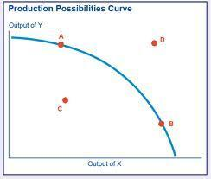  Where output of Y can be considered as Luxury goods and Output of X can be considered as necessary goods.  - C is a point where a mix of necessary and luxury goods is being produced. Countries are always within the PPF.  - Any point on the PPF represents that the country is using all its F.O.P EFFICIENTLY and is functioning PERFECTLY – not really possible.  - Anything outside it is absolutely impossible.
24 | Actual and potential Output | Actual output is the “real” GDP (Gross domestic Product). Potential output is the targeted output set by the government. Difference between the two is UNDEREMPLOYMENT
25 | Economic Growth and Economic development on the PPF | Economic growth occurs on the PPF when the curve goes outward. In other words, that is described as the increase in the ability to produce goods and services. (Item 5)  Economic Development occurs when the ability to produce necessary goods and services has increased and people can afford more and can produce more necessary goods.(Item 6) | Refer to Dictionary Item 5,6
26.1 | Rationing systems – Free market Economies | Also known as a private enterprise economy or capitalism, in a free market economy, prices are used to ration goods/services. All production is in the private hands and demand and supply are left free to set wages and prices in the economy. Should work relatively efficiently with a few cases of shortages or surpluses. | Most/the whole world. Today all countries have a MIXED economy where there is a mix of the market and the government. Market usually takes most decisions and government only intervenes when required.
26.2 | Rationing Systems – Planned Economy | Also known as a centrally planned economy or communism, in planned economies, decisions such as what to produce, how to produce, for whom to produce are taken by a central body, in this case the government. | The USSR in the 1980’s where the economy just collapsed because it didn’t function well enough.
27 | What to produce? | The government decides what goods/services to produce and how much of each to provide. More of one means less of the other (relates to Opportunity Cost[further described in dictionary item 20])  The private sector decides what to produce but it is done actually by the market. Firms will produce products that have the highest demand and will supply in those areas only.
28 | How to produce? | A firm’s aim is to make maximum profit possible. This is only possible by producing efficiently. The more efficient production is, the lower the costs of production are  The use of a factor of production depends on how expensive it is and how productive it is. If labour is cheap and as productive as machinery, then a firm may choose labour intensive production. If machines are more productive, then they may choose capital intensive production.
29 | For whom to produce? | Factors of production earn incomes – incomes used to purchase goods/services → Higher level of income = higher demand for goods/services  It’s possible to allocate on price to those with an effective demand. However ability to pay for a good/service may not be the only basis for allocation decision. There are other criteria in other sectors eg: need & equity
30 | Mixed Economies | An economic system in which both the state and private sector direct the economy. The basic economic coordination is done by the market. Means of production are mainly under private ownership. Government intervenes by bringing about economic policies, subsidizing firms/industries and also helps counteract economic downturns. | Cuba, Germany, USA, etc. etc.
31 | Public Sector | This is concerned with the government’s role in the economy – how governments can deal with failure of markets to achieve efficient outcomes.
32 | Private Sector | It’s the part of the economy, sometimes referred to as the citizen sector, which is run by private individuals or groups, usually as a means of enterprise for profit, and is not controlled by the state.
33 | Central Planning | The main body that directs and plans economic activity. A centrally planned economy is an economy where decisions on what to produce, how to produce and for whom are taken by the government. | For example, in planned economies, it’s the government, whereas in free market economies, there isn’t any central planning body.
34 | Free markets | A market where the price of a product is determined by the supply and demand than being subjugated to governmental regulation.
35 | Economies in transition | An economy that is changing from a centrally planned economy to a free market economy. | The USSR was an economy that transited from a centrally planned economy to a free market economy. Countries in this case split up as well and formed multiple economies where every country had a free market economy.
36 | Traditional Economy | A Traditional economy refers to countries that have their economy based on basic economic activities of hunting, gathering, or farming. A traditional economy is basically an economic system in which resources are allocated by inheritance, and which has a strong social network and is based on indigenous technology and methods. | African countries and some Asian countries like Bangladesh, Burma that rely a lot on agricultural production for growing food and creating jobs.
37 | Planned/Command Economy | A planned economy is an economic system in which decisions regarding production and investment are embodied in a plan formulated by a central authority, usually by a government agency. | North Korea, Russia, Iran etc.
38 | Empirical Testing | In economics, "empirical" generally refers to statistical or econometric analysis of numeric data. It is used generally to test economic theories
39 | Glut | A glut is when there is an oversupply of goods and when supply exceeds demand to an extent where price starts to fall.
40 | Commodity | In economics, a commodity is the generic term for any marketable item produced to satisfy wants or needs. Economic commodities comprise goods and services. Commodity is applied to goods only. It is used to describe a class of goods for which there is demand, but which is supplied without qualitative differentiation across a market. | Coffee, Tea are commodity cash crops. Petroleum, copper are also commodities because they satisfy one’s needs or wants.
41 | Cost and Benefit Analysis | This is a systematic process for calculating and comparing benefits and costs of a project, decision or government policy. It has two purposes; determining if it is a feasible/just/sound project and to provide a basis for comparing projects. It involves comparing the total expected cost of each option against the total expected benefits, to see whether the benefits outweigh the costs, and by how much. | Floor Space  Will the machine fit in the same space currently occupied by the three workers?  Installation  What will it cost to remove the manual stampers and install the new machine? Will you have to cut a hole in a wall to get it in or will it fit through the door? Will you need special rollers or machinists with special skills to install it?  Operator?  Somebody has to operate the machine. Does this person need special training? What will the operator's salary, including overhead, cost?  * Environment  Will the new machine be so noisy that you have to build soundproofing around it? Will the new machine increase the insurance premiums for the company?  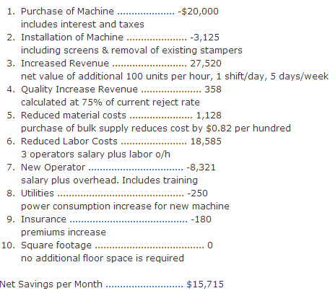
42 | External Cost | An external cost occurs when producing or consuming a good or service imposes a cost upon a third party. If there are external costs in consuming a good (negative externalities), the social cost will be greater than the private cost. The existence of external costs can lead to market failure. This is because the free market generally ignores the existence of external costs. | Driving a car can impose a private cost on the driver (cost of petrol, tax, cost of the car). However, driving the car can create costs to other people in society like, greater congestion and slower journey times for others, cause of death for pedestrians and pollution and health related problems.  Producing chemicals can cause pollution to air and water. The diagram shows how the existence of external costs will cause the social marginal cost to be greater than the private marginal cost. Therefore in a free market there will be overconsumption of the good (Q1) and social efficiency will occur at Q2 where SMC = SMB  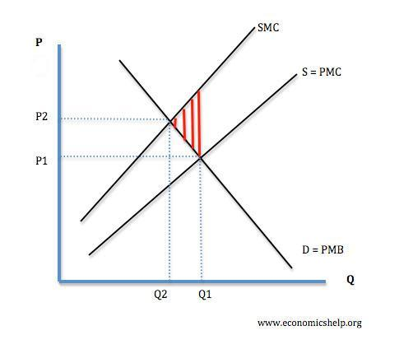
43 | External Benefit | An external benefit occurs when producing or consuming a good causes a benefit to a third party. The existence of external benefits (positive externalities) means that social benefit will be greater than private benefit. | A bee keeper produces honey, but as external benefit, his bees help to fertilize the nearby fruit trees.  In a free market, goods with external benefits can be often under-consumed because the free market ignores the external benefit to others.  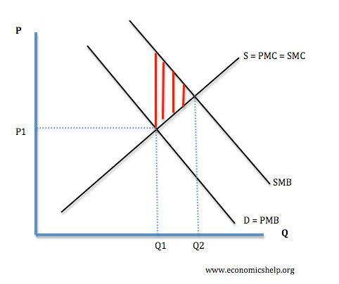
44 | Wealth | In economics, wealth is the net worth of a person, household, or nation, that is, the value of all assets owned net of all liabilities owed at a point in time. For national wealth as measured in the national accounts, the net liabilities are those owed to the rest of the world. The term may also be used more broadly as referring to the productive capacity of a society or as a contrast to poverty. Analytical emphasis may be on its determinants or distribution. | Wealth may be measured in nominal or real values, that is money out of a given date or adjusted to net-out price charges.
45 | Stock of goods | A quantity of goods/something accumulated for future use. | A stock of provisions. A stock of new goods for supply to the market.
46 | Circular flow of Income | This refers to a simple economic model which describes the reciprocal circulation of income between the government, consumers and the producer. | There are two types of models that can be considered: Microeconomic(occurring between the firm, government and the household) and Macroeconomic (occurring in the complete economy)  Macroeconomic:  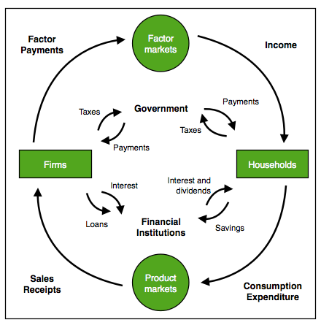  Microeconomic:  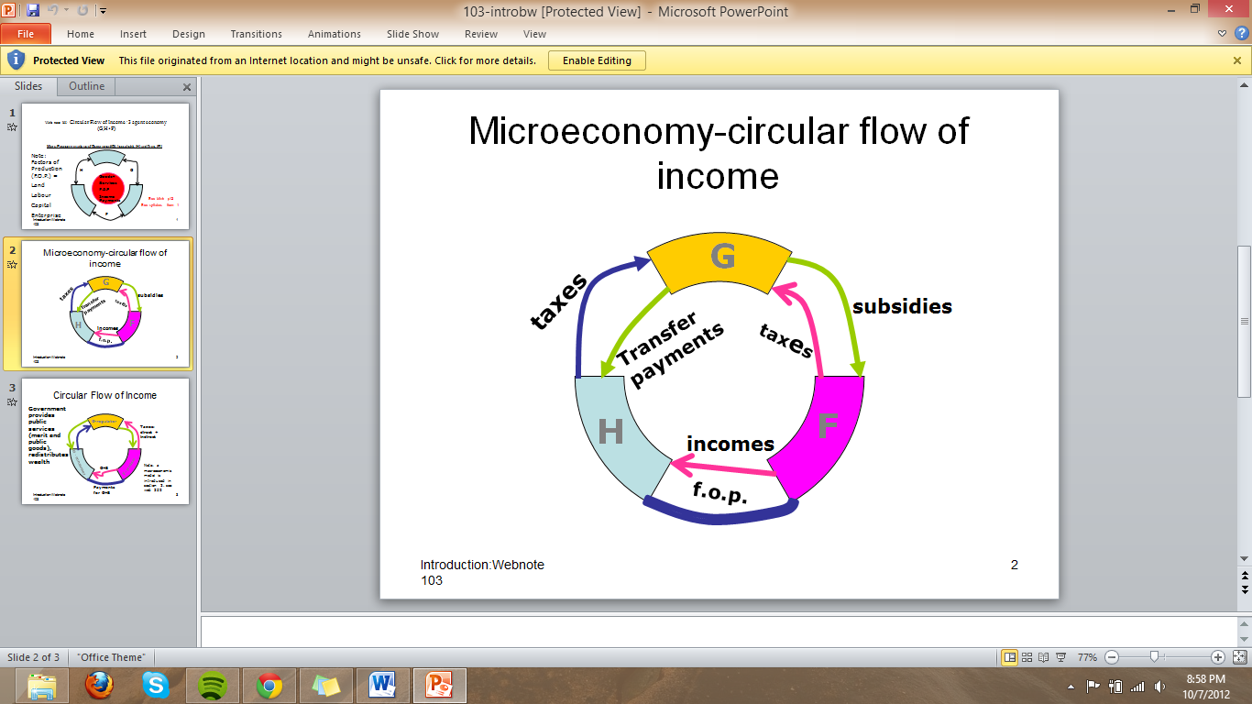
47 | Business Cycle Diagram | The recurring and fluctuating levels of economic activity that an economy experiences over a long period of time. The five stages of the business cycle are growth (expansion), peak, recession (contraction), trough and recovery. | 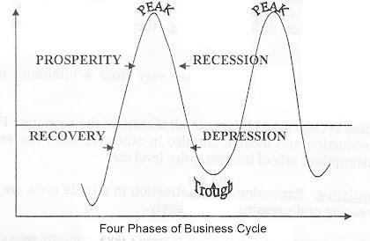  The four phases of the Business Cycle
48 | Human Development Index (HDI) | A term used to measure and rank countries’ levels of social and economic development based on four criteria: Life expectancy at birth, mean years of schooling, expected years of schooling and gross national income per capita. The HDI makes it possible to track changes in development levels over time and to compare development levels in different countries. | 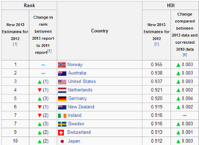  Different HDI values of countries putting them in ranked positions. All countries above are developed countries.
49 | Human Poverty Index (HPI) | An indication of the standard of living in a country. It was considered to better reflect the extent of deprivation in developed countries compared to the HDI

