Dictionary - Section 1 Microeconomics
Item Number | Term | Definition | Example/Diagram
1 | Law of Demand | “Everything else kept constant, more will be demanded at a lower price than at a higher price.” | According to the law of demand, at low prices, people will buy more than the amount they’ll buy at low prices. Here is a sample table of values  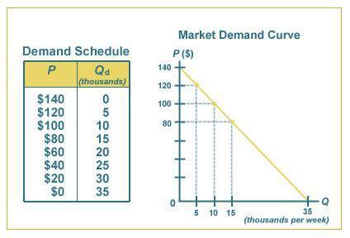
2 | Demand Function | It is a relationship between quantity demanded and price. The relationship can be shown as an equation mathematically.  Qd = a – bP  Where “a” is a constant of representing non-price determinants of demand. A change in ‘a’ will shift the whole demand curve to the left or the right while change in ‘b’ will change the slope (elasticity) of the demand curve. | 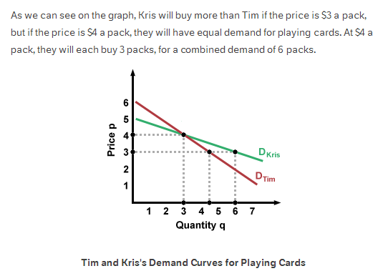
3 | Supply Function | The supply function is the relationship between quantity supplied and the price. The relationship can be shown mathematically as an equation.  Qs = c + dP  The constant ‘c’ represents the non-price determinants of supply. A change in ‘c’ will shift the whole supply curve to the left or right while a change in ‘d’ will change the slope (elasticity) of the supply curve.
4 | Shift in Demand | A shift in the demand curve occurs when there is a change in any non-price determinant of demand resulting in a new demand curve. Non-price determinants of demand are those things that will cause the demand to change even if the price remains the same. | 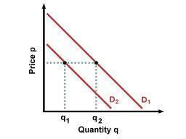  In this case, notice how the price is the same however quantity demanded has changed. This is because of one of the change in one of the non-determinants of demand. (item 4 on syllabus).
5 | Shift in Supply | A shift in the supply curve occurs when there is a change in any non-price determinant of supply resulting in a new supply curve. Non-price determinants of supply are those things that will cause the supply to change even if the price remains the same. | 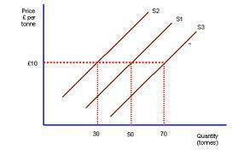  Notice how the price remains the same however the supply has change to two different curves. This would happen at the same time but would happen over a period of time because it takes a lot of time for the firm to react to a change in price and alternate their QS. There may have been a change in the non-price determinant of supply which is why there was a shift in the supply curve. (item 10 on the syllabus)
6 | Substitute Goods | Substitutes are goods that can be used for the same purpose and are in competition with each other. They are therefore alternatives of each other. | Different brands of one product, margarine or butter, tea or coffee, playstation or xbox, Coke or pepsi etc.
7 | Complementary Goods | Two goods that are consumed at the same time and work together. | Coffee and a coffee machine, CD and a CD player. Increase in the demand for one of the products would result in the increase in the demand of the complement as well. It would work also the other way around where if the complement’s demand goes up, the demand of the good goes up as well.
8 | Movement in Demand | Change in the price of a good results in the change of the quantity demanded. This results in movement along the same demand curve. Up the demand curve slope is known as contradiction in demand and down the demand curve slope is known as extension in demand | 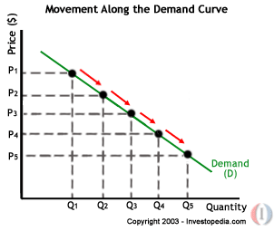  Notice how there is a change in the price and as the price changes, there is a change in the demand as well causing movement along the demand curve
9 | Movement in Supply | Change in the price of the good results in the change in quantity supplied. As price increases, supply increases | 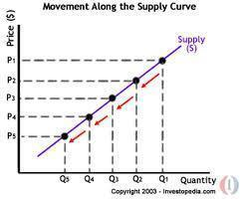  Notice the change in the price causing the change in quantity supplied. In an increase in price, there is an increase in supply, and in a decrease in price, there is a decrease in supply.
10 | Equilibrium | Market equilibrium is achieved when both the curves are brought together thus creating an intersection which is known as the Equilibrium. At this price, the quantity demanded = the quantity supplied. | 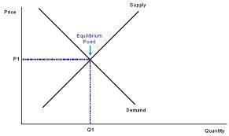  The intersection is known as the equilibrium. The amount supplied and demanded is equal and it can be said, that at this price the market is stable
11 | Clearing Price | The clearing price is also known as the price at the equilibrium. It is known as the market clearing price because at this price everything produced will be sold. | In the diagram above, the price P1 is the clearing price.
12 | Price Control | Government mandated minimum or maximum prices that can be charged for specific goods. Government sometimes implements price controls when prices on essential items such as food or oil are rising rapidly. Also include price floors and price ceilings. | During inflation or times of crises, government fixes the price of certain products so that it’s affordable for the economy.
13 | Monopolistic Competition | A type of competition within an industry where:  1. All firms produce similar yet not perfectly substitutable products.  2. All firms are able to enter the industry if the profits are attractive.  3. All firms are profit maximizers.  4. All firms have some market power, which means none are price takers.
14 | Perfect Competition | A market structure in which the following five criteria are met:  1. All firms sell an identical product.  2. All firms are price takers.  3. All firms have a relatively small market share.  4. Buyers know the nature of the product being sold and the prices  charged by each firm.  5. The industry is characterized by freedom of entry and exit.  It is a theoretical market structure and is primarily used as a benchmark against which other market structures are compared.
15 | Oligopoly | A situation in which a particular market is controlled by a small group of firms.  In an oligopoly, it is two firms controlling the market. | The television industry of the USA is an oligopoly of seven companies: The Walt Disney Company, CBS corporation, Viacom Comcast, Hearst Corporation, Time Warner and News Corporation
16 | Monopoly | A situation in which a single company owns all or nearly all of the market for a given type of product or service. | The British East India Company was a legal trading monopoly in 1600.
17 | Productive Efficiency | Concerned with producing goods and services with the optimal combination of inputs to produce maximum output for the minimum cost. | To be productively efficient means the economy must be producing on its production possibility frontier.  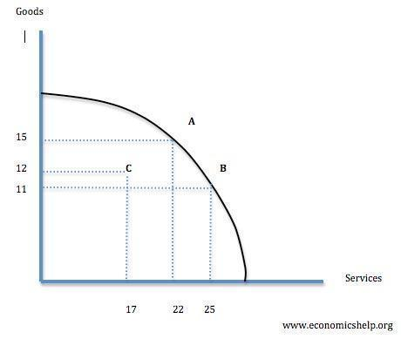  Points A and B are productively efficient whereas C is not because you could produce more goods or services with no opportunity cost.
18 | Economic Efficiency | A broad term that implies an economic state in which every resource is optimally allocated to serve each person in the best way while minimizing waste and inefficiency. When an economy is economically efficient, any changes made to assist one person would harm another. In terms of production, goods are produced at their lowest possible cost, as are the variable inputs of production. It is also known as allocative efficiency where markets are allocating resources efficiently. A market will be allocative efficient if it is producing the right goods for the right people at the right price. | The PPF can apply here as well.
19 | Subsidy | A payment made to firms/consumers designed to encourage an increase in output. A subsidy will shift the supply curve to the right and therefore lower the equilibrium price in a market. | 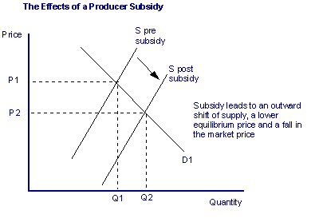  Example - US Cotton Industry
20 | Indirect Tax | Taxation on expenditure. It is an addition to the price imposed on the sale of goods and services by the government. | VAT and taxes on alcohol, tobacco and petrol. VAT applies everywhere and every country would have a different percentage for VAT.
21 | Direct Tax | Taxes paid to the government directly by the persons on whom it is imposed. | Income Tax
22 | Economies of Scale | The increase in efficiency of production as the number of goods being produced increases. A company that achieves economies of scale lowers the average cost/unit through increased production since fixed costs are shared over an increased number of goods.  External Economies – The cost per unit depends on the size of the industry  Internal Economies – The cost per unit depends on the size of the firm. | 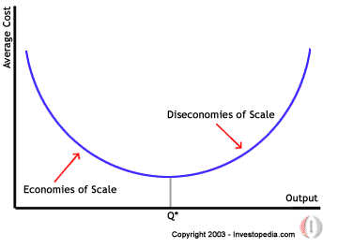
23 | Diseconomies of scale | A situation in which economies of scale no longer function for a firm. Rather than experiencing continued decreasing costs per increase in output, firms see an increase in marginal cost when output is increased.
24 | Price Elasticity of Demand (PED) | This refers to how much the quantity demanded changes when the price of the product changes. It is the responsiveness of demand for a product following a change in its own price.  Formula:  Percentage change in QD divided by percentage change in price | 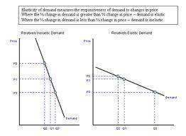  Notice how in the first diagram, as price changes in huge steps, there is not a very big change in demand making it inelastic, whereas in diagram two, a change in price in huge or even small steps results in big changes in demand making the demand elastic for the product.
25 | Price Elasticity of Supply (PES) | This refers to the responsiveness in the quantity supplied when there is a change in the price of the product. It measures the relationship between change in quantity supplied and change in price.  Formula  Percentage change in quantity supplied divided by the percentage change in price | 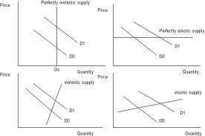
26 | Income Elasticity of Demand (YED) | This measures the relationship between a change in quantity demanded for a good X and a change in real income.  Formula:  Percentage change in demand divided by percentage change in income | 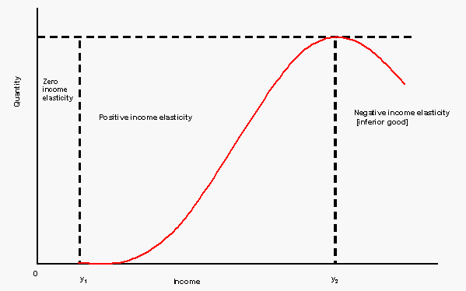  Zero Income elasticity Positive income elasticity Negative income elasticity (inferior good)
27 | Cross Elasticity of Demand (XED) | Measures the responsiveness in the quantity demanded of one good when a change in price takes place in another good. This measure is calculated by taking the percentage change in the QD of one good divided by the percentage change in the price of the substitute good. It also works with complement goods. | The weak substitutes like tea and coffee have a low XED. Tesco bread and Sainsbury’s bread are close substitutes so XED is higher.  XED is negative in the case of complementary goods.
28 | Unit Elastic | An elasticity alternative in which any percentage change in price causes an equal percentage change in quantity giving a value of 1 which makes it unit elastic. | Unit elastic demand curve  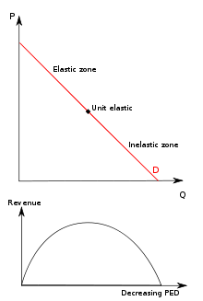  Unit Elastic supply curve  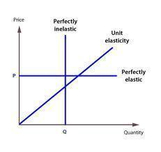
29 | Inelastic | Demand/Supply of a product is said to be inelastic when a change in price doesn’t really affect the quantity supplied/demanded very much. Big changes or small changes in price would minorly affect the change in the quantity demanded/supplied. | Examples would often include products that are necessary and ones that people cannot really do without. An inelastic demand/supply curve is shown in item 24 and 25 (dictionary item) (Further explanation in range of values in syllabus items)
30 | Elastic | Demand/Supply is said to be elastic when a change in price affects the quantity demanded/supplied very significantly. Big/Small changes would majorly affect the quantity demanded/supplied. | Luxury goods usually have a very elastic demand/supply. The reason being that these goods aren’t really goods that we can’t survive without and people can do without them. Big price increases would result in people buy less/no amount of that product. (Example of an elastic curve is given in item 24,25.) (Further explanation on range of values in syllabus items.)
31 | PED and Total Revenue | When deciding on price and changing supply and demand, the firm selling/producing the product has to think about how the change in the price of the product would affect the revenue they are getting. If the demand is inelastic, it usually results in more revenue than what the producer was getting before the price change, but if the demand is elastic, then it would result in the firm getting less revenue than what it was getting before the price change. | 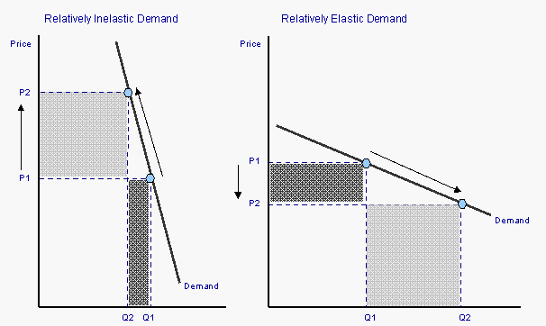  Notice the change in revenue with respect to the change in prices. The bigger box represents a great amount of revenue gained/lost.
32 | Vertical Demand Curve | Although theoretical, this is when the demand is completely inelastic and regardless of the price, the quantity demanded would be the same. It is known as being “perfectly inelastic” | 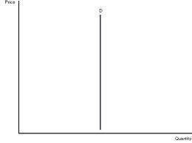
33 | Horizontal Demand Curve | This again is a theoretical value, however this represents that the demand is completely elastic, and at one price, there would be a big fluctuation the quantity demanded. It is known as being “perfectly elastic” because any change in price would result in zero quantity demanded. | 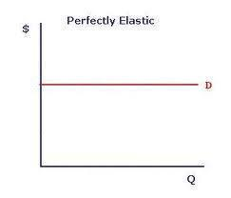
34 | Vertical Supply Curve | Here, at any price, the firm is ready to produce and supply only a fixed amount. Also known as being “perfectly inelastic” | 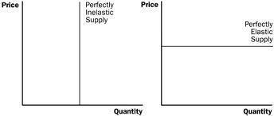
35 | Horizontal Supply Curve | This is when at one particular price, the firm is ready to produce and supply any quantity of goods. Also known as being “perfectly elastic” because any change in price would result in zero quantity supplied.
36 | Inferior goods + YED | Inferior goods have a negative income elasticity of demand. Demand falls as income rises.
37 | Factors affecting PED | There are six factors affecting the price elasticity of demand.  1. Availability of Substitutes  2. Degree of Necessity or Luxury  3. Proportion of income required by the item  4. Time period considered  5. Permanent or temporary price change  6. Price points(decreasing the price from $2.00 to $1.99 may result in greater increase in quantity demanded than decreasing it from $1.99 to $1.98.)
38 | Factors affecting PES | 1. How much the costs rise as input is increased(production costs)  2. The time period considered  3. The ability to store a stock
39 | Total Profit (TR-TC) | Total profit is the revenue the firm receives (total revenue) subtracted by the total production costs (total cost) it bears while producing the product.  Formula  TR – TC = TP
40 | Market Failure | A situation where in any given market, the quantity of a product demanded by consumers doesn’t equate to the quantity supplied by suppliers – a disequilibrium.  It has negative effects on the economy because the social costs of producing a good/service are not minimized thus resulting in a waste of resources.  It occurs when the free market fails to deliver an efficient allocation of resources – result, a loss in economic and social welfare.  Occurs when the price mechanism results in an inefficient or grossly unfair allocation of resources. | Stock Market Crash (Real Life)  The Great Depression (Real Life)
41 | Marginal Social Costs (MSC) | The total cost to society as a whole for producing one further unit, or taking one further action in an economy. This total cost of producing one extra unit of something is not simply the direct cost borne by the producer but also include the costs to the external environment and other stakeholders.  Calculated as :  MSC = MPC + MEC  MSC – Marginal social costs  MPC – Marginal Private costs  MEC – Marginal External costs (positive) | Coal Plant polluting a local river. If the coal plant’s marginal social costs are more than its marginal private costs, the MEC must be positive existence of a negative externality or external effect on the environment.  Cost of the produced energy is more than just the rate charged by the company, as society must bear the costs of a polluted river and effects of that action.  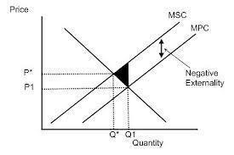
42 | Marginal Private Costs (MPC) | Marginal Private cost is the cost to the firm often combined with any external cost to give the total social cost of the production of a good or service | 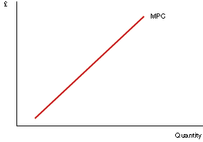
43 | External Benefit | Also known as a positive externality, is a benefit that a transaction or activity provides to a party that is not part of the transaction or activity.  It exists when an individual or firm making a decision doesn’t receive the full benefit of the decision. The benefit to the individual or the firm is less than the benefit to the society. | Immunization prevents from getting a disease but has a positive effect of the individual not being able to spread the disease to the others.  In the diagram,  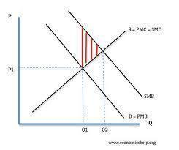
44 | External Cost | Also known as a negative externality, are negative costs that are incurred by a third party. It includes effects like pollution, and effects of secondary smoking. | 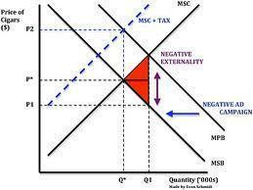
45 | European Trading Scheme (ETS) | The European Union Emissions Trading Scheme was the first large emissions trading scheme in the world. Its aim is to combat climate change. It works on the cap and trade system where there is a limit to the amount of certain greenhouse gases than can be emitted from factories and power plants. Companies receive emission allowances which they can buy and sell from one another as needed.
46 | Extending property rights | Externalities can arise because property rights aren’t fully allocated, for example nobody owns the atmosphere or oceans. An alternative to regulation is the extension of property rights. It gives water companies the right to charge companies who pollute the rivers and seas. Extending property rights is a method of internalising the externality. | If you decided to throw a brick through the window of my house I would be well within my rights to expect legal redress. The reason is that you have caused damage to my property and provided I can prove it was you who caused the damage and that I am the legal owner of the house I can expect compensation to put right the damage (replacing the window pane might be one aspect but also for any emotional trauma caused!) With things such as rivers, streams, land and air it is less easy to establish who are the legal owners
47 | Tradable Permits | A governmentally granted licence to pollute to a certain level that can be bought and sold between firms and factories.
48 | Nationalization | Refers to the process of a government taking control of a company or industry. When nationalization occurs, the former owners of the companies may or may not be compensated for their loss in net worth and potential income. | In response to the September 11 attacks, the airport security industry was nationalized by the US government and put under the authority of the Transportation Security Administration
49 | Privatization | The transfer of ownership of property or business from a government to a privately owned entity. | Deutsche Bundespost became Deutsche post, Deutsche Telekom and Deutsche Postbank
50 | Merit Goods | Merit Goods are products like education which consumers may undervalue but the government believes they are good for the economy as they exhibit positive externalities. Merit goods would therefore be under provided by a pure free market economy. People do not take into account positive externalities when they decide how much of the good or service to consume. (refer to positive externalities for detail) | 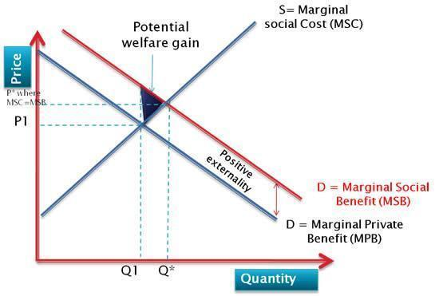  The graph of a merit good. It exhibits a benefit to the society. Example, health care services, education etc.
51 | Public Goods | Goods that would not be provided in a pure free market system. They display the characteristics of non-rivalry (consumption by one person doesn’t affect the amount available for another) and non-excludability (once the good is provided, it is not possible to stop people from benefiting from it). | Street lighting, Flood barrier, Pedestrian pavement, etc.
52 | Positive Externalities of P & C | Production:  MSC < MPC. The optimum equilibrium for society would be where the marginal social cost is equal to the marginal social benefit (Q!). However, a free market left to itself will produce where the marginal private cost is equal to the marginal private benefit (Q^). If there are positive externalities in production, a private market will therefore tend to under-produce a good.  Consumption:  MSB > MPB. The optimum equilibrium for society would be where the marginal social cost is equal to the marginal social benefit (Q!). However, a free market left to itself will produce where the marginal private cost is equal to the marginal private benefit (Q^). If there are positive externalities in consumption, a private market will therefore tend to under-provide a good. | 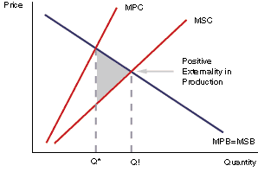  Graph for a positive externality in production  A large printing firm provides high quality training for its employees. There is a cost to the firm. When the employees leave the firm and go to other firms, benefit firms that don’t have to spent money on training their new workers. Society has gained from the training given by the printing firm. MPC >MSC  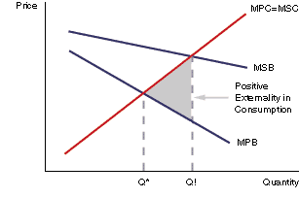  Graph for positive externality in consumption  Consumption of healthcare positive externality for society. People are healthier, they will not pass illnesses around, economy is more productive – benefit to the whole population. MSB of healthcare consumption > MPB
53 | Negative Externalities of P & C | Consumption:  MSB < MPB  The optimum equilibrium for society would be where the marginal social cost is equal to the marginal social benefit (Q!). However, a free market left to itself will produce where the marginal private cost is equal to the marginal private benefit (Q^). If there are negative externalities in consumption, a private market will therefore tend to over-provide a good.  Production:  MSC > MPC. The optimum equilibrium for society would be where the marginal social cost is equal to the marginal social benefit (Q!). However, a free market left to itself will produce where the marginal private cost is equal to the marginal private benefit (Q^). If there are negative externalities in production, a private market will therefore tend to over-produce a good. | 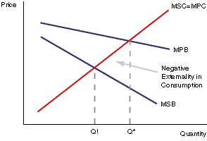  Graph for Negative externalities in consumption  People who smoke enjoy private benefits of smoking but this will create external costs for other people. – Passive or second hand smoking.  Costs to others include lung cancer, asthma etc.  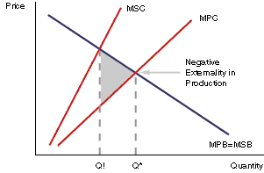  Graph for negative externalities in production  Paint factory emits fumes harmful to people in the area (third party) then => cost of community is > than cost of production paid by the firm  Firm has its private costs, however it creates external costs. Marginal social cost of production > than marginal private cost. MSC = MPC + EC(external cost)
** P&C = Production and Consumption

