Criterion F: 3 Questions

Question 1: What is the Wordcount on this IA?

Article
The post-Brexit pound – how sterling's fall affects you and the UK economy

Bargain-hunting tourists are flocking to the UK to exploit the plunging pound but Britons are burning money on their summer holiday in Europe.
The dramatic slide in sterling since the Brexit vote has given British holidaymakers enough pain already. But there was a further shock in store this week after some airports offered less than €1 to £1 at two major airports.
At Stansted and Luton, travellers found they could not even exchange £1 for €1, which at least prepared them for the financial squeeze at their destinations. Those holidaying in Europe are finding that meals, coffees, drinks and other items are typically at least 22% more expensive than a year ago.
There has, however, been a benefit for the British economy. On Thursday, official data showed that retail sales leapt 1.4% in July following a drop in June – apparently helped by an influx of big-spending overseas tourists from the likes of the US, China and Hong Kong.

Foreign visitors to the UK

It’s not just London experiencing a surge in visitors exploiting the cheap pound, according to Ryanair. It said there had been a surge in “close-in bookings” – those made six weeks before flying – from southern European travellers heading to Manchester, Liverpool, Leeds and Scotland, as well as the capital.
“For so long it has been, ‘I love going to London but it’s so expensive.’ Now it’s so much cheaper, we’ve seen a big increase in short-term bookings to London and regional UK,” said Kenny Jacobs, Ryanair’s chief marketing officer.
However, Ryanair’s biggest increase in business has come from Americans and Chinese flying to Europe and then using its network to come to Britain and shop. “We are carrying 20% more Americans this summer, and have seen a 10% increase in the number of Chinese coming into places such as Rome and Berlin, then using Ryanair to get around Europe. It is absolutely linked to the weakness of sterling.”
According to this week’s official retail sales data, purchases of watches and jewellery were up 16.6% on the year, a rise largely attributed to foreign buyers. For European and Chinese visitors, prices in British stores are now roughly 18% and 13% below mid-August 2015. For Americans it is around 16%, while for Australians everything is now a fifth cheaper.
Meanwhile, CAISSA Touristic, one of China’s leading tour operators, said that over the past two months it had seen a 20% increase in inquiries and bookings involving travel to the UK.

British tourists abroad

The weak pound has added hundreds of pounds to the cost of many people’s summer holidays. According to M&S Bank, the typical cost of a one-week overseas summer holiday for a family of four, including flights, accommodation, meals and spending money, had risen by £429 compared to last year due to the fall in sterling.
In Sorrento in southern Italy, the typical cost of a three-course evening meal for a British family of four, including a bottle of wine and soft drinks, has effectively risen by 22% in a year, with the bill around £86 this year compared with just under £71 a year ago, based on recent exchange rates. Corfu in Greece has recorded a similar percentage rise – from around £42 to £52. Meanwhile, the typical cost of a glass of wine in a Sorrento bar has effectively leapt 53% in a year, from £1.41 (€2) in August 2015 to £2.16 (€2.50). These figures were provided by Post Office Travel Money, which publishes an annual family holiday report. It said bars and restaurants in several of the resorts surveyed had cut their prices to attract tourists.

The staycation

Are the British swapping the Balearic Islands for the Isle of Wight? According to tourist authorities on the Isle of Wight, there has been a “very significant leap” in its website traffic, while Visit East Anglia said its enquiries had risen by a quarter.
But talk of a staycation boom may be premature. Ryanair said that it carried a record number of British holidaymakers to Europe in July, the first full month after the referendum.
“You are still getting a pint of lager for £1 in parts of Spain and Portugal, while you’ll struggle to find it anywhere under £2.50 in Britain,” said Jacobs at Ryanair. “When people like Nigel Farage say that Brexit will encourage Brits to holiday at home, he’s talking absolute nonsense. Since Brexit we’ve not seen any drop-off in business. If money is tight next year, people won’t stop going on holiday abroad – they will more likely drop down from a four-star hotel to a three-star.”
This may already be happening: the website TravelSupermarket said it was seeing a lot of interest in last-minute summer sun package holidays, particularly in the £300-£400 per person per week bracket. “We’re currently seeing all-inclusive four-star holidays to Turkey in early September for as little as £230 per person,” it added.

Bureaux de change

Researchers from currency specialist Caxton FX found that the Moneycorp exchange booth at Stansted airport was at one point offering just €0.9915 for each £1 exchanged. The rate on offer at the ICE (International Currency Exchange) bureaux de change at Luton airport was even lower at €0.9900.
One recent survey suggested that holidaymakers travelling to Europe can expect to be around 7% better-off if they sort out their euros in advance rather than buying them at the airport. But checks carried out by the Guardian suggest the figure could be double that in some cases.

Northern Ireland

Northern Ireland, which voted to stay in the EU, has at least benefited from the post-Brexit plunge in the pound. At the Quays shopping centre in Newry, just four miles from the border with the Republic, the fall in the pound is a huge relief following several tough years after the Irish economy tanked. This week, a sizeable proportion of the vehicles in its car park belonged to bargain-hunting shoppers up from the south.
Cathal Austin, the manager at Quays, said: “We have seen an increase since the pound has fallen, and we are expecting a much bigger increase for Halloween and Christmas.”
Economics IA

In the past moths there have been many events that have affect on the exchange rates of currencies, but one of the most crucial ones was the Brexit. This article is about how the Brexit has affected the exchange rate of the pound, especially seen at exchange rate bureau at the airport. Currency is a system of money in general use in a particular country. Exchange rates is the value of one currency for the purpose of conversion to another. The withdrawal from the European union is widely know as “the Brexit”. In text there will be a clear analysis regarding 3.2 of the syllabus, which is exchange rates. If there is a decrease in the value of a currency, it leads to an increase exports.

Since June 23, 2016, when the Brexit was voted for in the UK, there has been a decrease in the value of the British pound and thus then lead to more exports of goods and higher revenue in Britain, “some airports offer less than 1euro to 1 pound”, “official data showed that retail sales leaped 1,4%”.
Diagram 1:
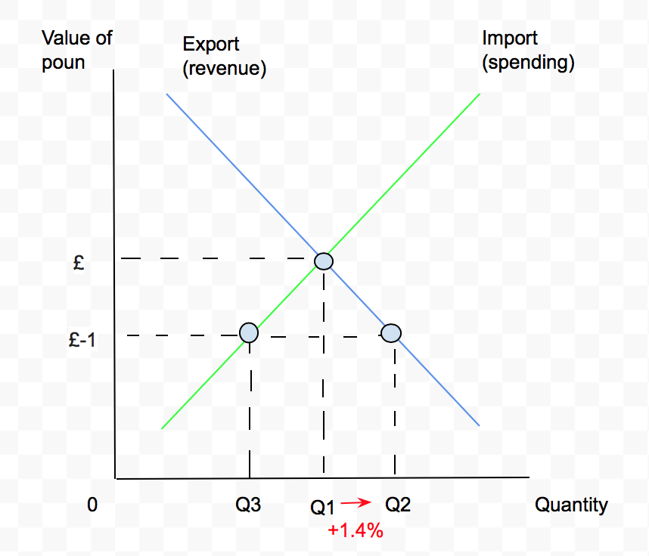

The Brexit has caused the devaluation of the British pound. Devaluation is the decrease or reduction in value of a currency. In diagram 1 above, it shows the affect of the devaluation of the pound. The decrease from £ to £-1 above, creates an increase in revenue Q1 to Q2 by 1.4%. The devaluation also leads to a decrease in Imports, because imports become more expensive. The decrease in value of the pound in comparison to any other currency, will lead to an increase in sales by foreign visitors, “For European and Chinese visitors, prices in British stores are now roughly18% and 13% below mid-August 2015”. The decrease in prices for foreign visitors implies that there will be an increase in quantity demanded for products, “I love going to London but its so expensive. Now its much cheaper”.

The devaluation has many advantages and disadvantages that affect the economy. An advantages of devaluation is that exports become cheaper as the value decreases. This then leads to more foreign buyers, which increases the domestic demand. This then could lead to an increase jobs in the export sector. The devaluation will also cause an increase in money flow in the economy. This increases aggregated consumption, demand and saving. These factors are crucial for economic growth, which means that economic growth can also be a advantage of devaluation. The domestic price stays the same, it is a major advantage for a country, because if there is a increase in foreign exchange happens without affecting the domestic value of their currency. The impact will mostly be felt by people who work in the importing and exporting sector, because they try to profit from small variations in value of a currency. Devaluation can lead to a more balanced trade deficit, because it leads to a decrease in imports and thus may balance the deficit since imports have become more expensive now. The disadvantages of devaluation are that imports become more expensive, for example an imported good or raw material immediately has an increase in price. The devaluation leads to an increase in money supply, this then increases the domestic demand. The high domestic demand creates an increase in prices, and this leads to inflation. Inflation may also be caused by firms lack of incentive to cut costs, because the firm only relies on the decrease in value of the currency to improve the competitiveness. In the long term the lack of incentive then causes low productivity. The decrease in value of the pound would also affect the purchasing power party of citizens, because any holiday or purchase outside of the country would be more expensive. If there is a large or quick devaluation, it might repel international investors. Investors might be less willing to hold government debt, because in the end it reduces the value of their holdings. Any foreign debt also for consumers will be a disadvantage. Any foreign debt like a mortgage in a foreign country, will increase due to the devaluation. The devaluation might also affect the creditworthiness of a country, on a a global marke the country might be seen as unreliable. The economic theory that there is a increase in exports of a country due to evaluation is true and can be seen in the article. As positive as the affect might be there are also as many downsides of devaluation.
745 Words

807
Word Count =

807

807

Question 2:
How many words in this diagram title? Is there anything wrong with this in relation to criterion F ?

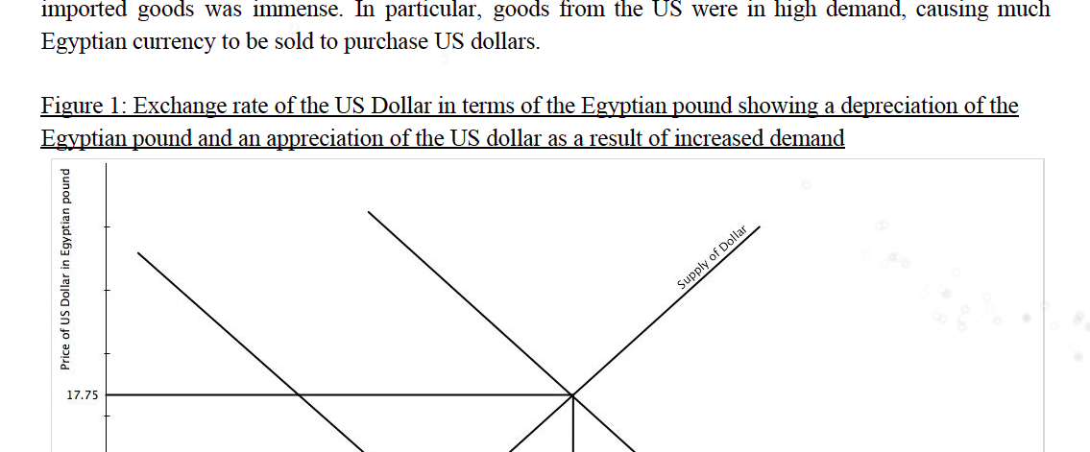

Collinson, Patrick, and Rupert Jones. "The Post-Brexit Pound – How Sterling's Fall Affects You and the UK Economy." The Guardian. Guardian News and Media, 19 Aug. 2016. Web. 15 Mar. 2017. <https://www.theguardian.com/business/2016/aug/19/the-post-brexit-pound-how-sterlings-fall-affects-the-uk-economy>.
Collinson, Patrick, and Rupert Jones. "The Post-Brexit Pound – How Sterling's Fall Affects You and the UK Economy." The Guardian. Guardian News and Media, 19 Aug. 2016. Web. 15 Mar. 2017. <https://www.theguardian.com/business/2016/aug/19/the-post-brexit-pound-how-sterlings-fall-affects-the-uk-economy>.

