Dictionary Section 4 – Individual Sections
Item Number | Term | Explanation | Diagram/Example
1 | Economic Growth | Economic Growth is a measurement of the change in a country’s national output, or Gross Domestic Product (GDP).  National income is a measure of adding up all the activity between one of the following; Goods & Services between firms to households, Expenditure between households to firms, and the payment factors from firms to households. This value is measured each year and the difference between the two is the economic growth. If the economy has a higher GDP we would say the economy has grown! | 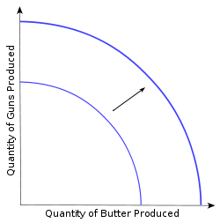  Further Explanation on term 5 in section 1 Dictionary
2 | Economic Development | Unlike economic growth, economic development is a measure of welfare (a measure of well-being). It is basically a measure of how a country is doing. The following factors are taken into account; Life Expectancy, Literacy Rate, expected time spent in schools, and the Gross National Income per capita. | Refer to term 6 in Section 1 Dictionary
3 | Physical Capital | In economics, physical capital or just 'capital' refers to any manufactured asset that is applied production, such as machinery. | Machinery, Buildings, Computers
4 | Human Capital | The skills, knowledge, and experience possessed by an individual or population, viewed in terms of their value or cost to an organization or country.
5 | Poverty | A state or condition in which a person or community lacks the financial resources and essentials to enjoy a minimum standard of life and well-being that's considered acceptable in society | Poverty is measured by the HPI which indicates what percentage of the population lives under the poverty line. This is one of the important indicators as to whether the economy is developing or not.
6 | Poverty Cycle | In economics, the cycle of poverty is the "set of factors or events by which poverty, once started, is likely to continue unless there is outside intervention. | 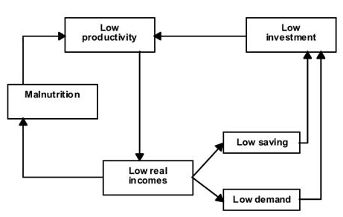  Further explanation on item 166
7 | Millennium (International) Development Goals | Even though there are differences and characteristics that describe developing countries and may hold countries back from development, attempts are made to set development goals adopted by all of them.  Goal 1: Eradicate Extreme poverty and hunger  Goal 2: Achieve universal primary education  Goal 3: Promote gender equality and empower women  Goal 4: Reduce child mortality  Goal 5: Improve maternal health  Goal 6: Combat HIV/AIDS, malaria, and other diseases  Goal 7: Ensure environmental sustainability  Goal 8: Develop a Global Partnership for Development | International Development is used in a very multi-disciplinary context of human development – the development of greater quality of life for humans. This was written in 2000 and was aimed to be achieved by the year 2015-2020.
8 | Resource Endowment | Resources within the borders of the country | This may include human and physical resources. Developing countries maybe poorly endowed with Human and physical resources. Human resources may include low skilled labour, poorly educated etc. whereas physical resources may include coal mines etc.
9 | GDP per Capita | Gross Domestic product is the measure of a country’s overall economic output divided by the average population of the country. It is the market value of all the goods and services produced in a country in a year divided by population. | 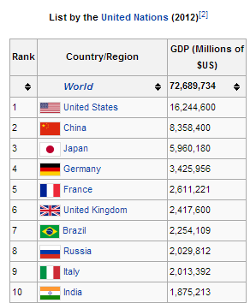
10 | GNI per capita | Gross National Income is the dollar value of the country’s citizens’ final incomes. It is found by dividing the dollar value of the country’s final income by the population of the country. | 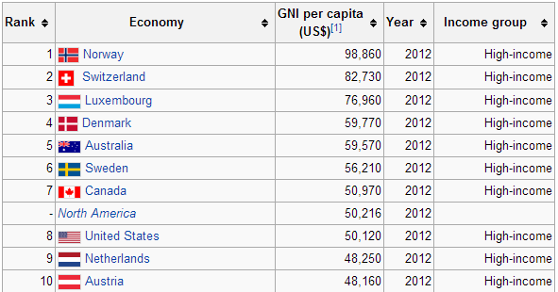
11 | Purchasing Power Parity (PPP) | A way of measuring what an amount of money in a certain currency will buy in different countries. Exchange rates between countries create a difference between what one currency can buy and how much the other one can buy. | 100 dollars can buy more in India than it can in the USA. One dollar is 540 rupees and can buy a lot more than what it can buy in the USA.
12 | Exchange Rates | How much one currency costs in terms of another. | One dollar is 54 Rupees whereas one Euro is 70 Rupees. One Euro would have a higher PPP in India than would one dollar (with reference to term of purchasing power parity)
13 | Composite Indicators of Development | These are indicators that take into account more number of factors than does the GDP and is more accurate. It looks at the broader picture as does economic development of country. It takes into account health, life expectancy, standard of living etc. | HDI is a good indicator of Development and is a composite indicator as it looks at a lot of factors.
14 | Human Development Index (HDI) | A tool developed by the United Nations to measure and rank countries' levels of social and economic development based on four criteria: Life expectancy at birth, mean years of schooling, expected years of schooling and gross national income per capita. | 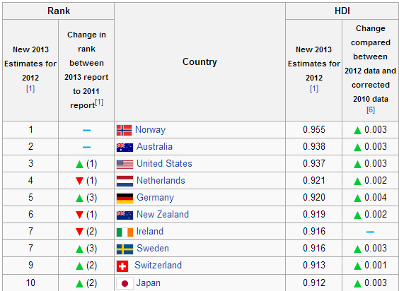
15 | Education and Health | Education – The process of being enlightened or taught something. In the case of economics, education would include schooling, education of skills to work and produce goods and services  Health – The physical or mental condition of a person. In the case of economics, health is something that is looked at from a development of the economy point of view. | Education and Health are factors that are taken into account by measures like that of the HDI. Health (life expectancy, death rate, birth rate etc.) talks about how the economy of a country is developing in terms of population’s health and whether it’s healthy and hygienic enough for it to develop.  Education on the other hand, is something that decides whether labour is skilled or unskilled and whether they are trained (educated) or not to be able to produce goods and services to serve to an economy.
16 | Micro Credit Scheme | It is an extension of loans given to poor people like farmers in the form of microloans which help kick starting a small business that a person would like to start and are designed to drive people into taking entrepreneurship.
17 | Use of Appropriate Technology | In terms of economics, the use of appropriate technology would include using technology that helps in increasing the amount of goods/services produced, that helps making work efficient and also reduces production costs. They save time, are efficient and should be sustainable. Also, it should be appropriate to the work it needs to do. | For painting cars in a factory, using a car body spray painting machine would be more effective and efficient rather than having manual labour spray paint the body of the cars. It would take less time and also help the firm reduce the number of employees it has to employ to spray paint a car.
18 | Empowerment of Women | Empowering women with rights to be able to stand for themselves and not having them to rely on others. It is to allow them to be able to speak for themselves and be able to create a sense of equality in terms of gender in the economy. | Women were granted the right to vote which allowed them an equal say in who the representative of the government should be. Women were allowed to be nominated for president and also for higher authorities in the government.
19 | Income Distribution | It is how a nation’s total GDP is distributed amongst its population.
20 | Barriers to Development | These are factors that are barriers to development for many developing countries. Four of which include  1. Over-specialization on a narrow range of products  2. Price volatility of Primary products  3. Inability to access International Markets  4. Long-term changes in the terms of trade | These barriers to development can cause a problem for the economy of developing countries. With such barriers, developed countries also could make it harder for developing countries to be able to develop economically and also be able to gain a better standard of living.  (Refer to items 172,173 for further detail)
21 | Over Specialization | Overspecialization here means the overspecialization of a developing country on a narrow range of products creating a very huge risk in losing a lot of revenue. Developing countries tend to over specialize on primary commodities that have an inelastic demand. This would mean that a small movement in demand could cause large price shifts and if price drops, then this could create problems for developing economies as they might suffer huge losses.
22 | Primary Products | Primary products are part of the primary sector of the economy where there is direct access to natural resources and this part of the economy extracts these resources. | Mining, extraction of oil and gas, Fishing, forestry
23 | Price Volatility of Primary products | Primary products have very inelastic demands and supplies. A small change in demand or supply could cause large fluctuations in the price. This could either cause gains or losses for the economy. | 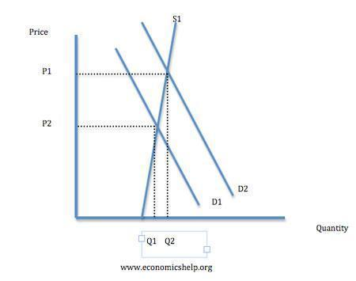  Notice how there is a huge price change when Q2 changes to Q1 and price dips from P1 to P2.
24 | Protectionism | An economic policy that is aimed at supporting domestic producers at the expense of foreign producers. This is normally done when the country is living through exports. It can be harmful as then the industries of the country don’t produce much thus reducing the growth of the economy and the industries.  (Further explanation on item 172) | Types of protectionism include Tariffs, Subsidies.  Cotton, America’s 25000 Cotton farmers share $3billion in government subsidies each year – encourages farmers to produce more and forcing down the world price, exporting their surplus to developing countries. LDC’s have no advantages of subsidies and hence could damage LDC’s producers.
25 | Import Substitution (Inward Oriented Strategy) | A trade and economic policy that advocates replacing imports with domestic production. ISI (Import Substitution industrialization) is based on the premise that a country should attempt to reduce its foreign dependency through the local production of industrialized products.  This promotes Economic Growth within a country and allows them to be more competitive on world markets in the long run.  - Choose a selection of goods  - Give subsidies to the firms producing them  - Place tariff barriers to keep out foreign imports | Adopted mainly by Argentina, Brazil, Mexico, Chile and Uruguay. As countries gained independence, like India, Nigeria and Kenya, they also adopted the strategy. The strategy started to fail eventually. Government overspending and the debt crisis led to the inability of governments to repay the loans they had taken in the 1980’s many of the countries were forced to go to the IMF for help.
26 | Export Promotion (Outward Oriented Strategy) | Also known as Export led growth. Trade and economic policy aiming to speed up the industrialization process of a country by exporting goods for which the nation has a comparative advantage. Growth is achieved through revenues and profits gained from exports of products. | Export-oriented industrialization was particularly characteristic of the development of the national economies of the Asian Tigers: Hong Kong, South Korea, Taiwan, and Singapore in the post-World War II period.
27 | Trade Liberalization | It is the act of removing trade barriers and making connections between economies/countries making it possible for them to trade. It includes the removal of tariff barriers, quotas, export subsidies and administrative legislation
28 | World trade Organization | It is the only global international organization dealing with the rules of trade between nations. The goal is to help producers of goods and services, exporters, and importers conduct their business.
29 | Bilateral/ Regional Trade Agreements | A trade pact is a wide ranging tax, tariff and trade pact that often includes investment guarantees. The most common trade pacts are of the preferential and free trade types are concluded in order to reduce (or eliminate) tariffs, quotas and other trade restrictions on items traded between the signatories.  Bilateral - two countries establish a preferential trade agreement between themselves  Regional - Multilateral arrangement between a number of countries in a geographical region
30 | Diversification | It is one of strategies for development of a developing country that a country might take into account. (note 174)  Moving from production and export of primary goods to production and export of manufactured and semi manufactured goods.
31 | FDI | Overseas investment by multinational corporations (MNC). An MNC is a firm that has productive capacity in a number of countries. The profit and income flows that they generate are part of the foreign capital flows moving between countries. | Tata Steel is an example of FDI in the USA.  FDI could create economic development or even economic growth as the government gain from the profits of the tax paid by the MNCs and could use this money to create beneficiaries for the economy. It would hence also result in an outward movement of the PPF eventually that is if the PPF turns out to be an advantage rather than a disadvantage.  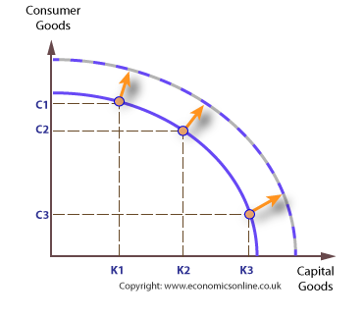
32 | MNC | A multinational is a large company owning subsidiaries and producing in a number of companies | Apple Inc.  Dell  Samsung  Coca-Cola  Hyundai  Mercedes Benz
33 | Low cost factor inputs
34 | Profit Repatriation | MNCs may want to repatriate their profits, transferring their profits back to the origin of the MNC. It is one of the disadvantages of having an MNC create an FDI in a country.
35 | ODA (Official Development Assistance) | Aid that is given to alleviate poverty in the long run of a country, and improve the welfare of individuals.
36 | NGO (Non-Government Organization) | Legally constituted corporations created by natural or legal people that operate independently from any form of government. They are non-profit businesses aimed at promoting development, sustainable development and humanitarian ideals | Oxfam
37 | Aid | Any assistance that is given to a country that would not have been provided through normal market forces. It is usually given to countries to promote the development of a developing country, improve quality of human resources or help people who have experienced a natural disaster | Money, Medical Services, Clothes, Food, Emergency aid
38 | Grant | Non-repayable funds disbursed by one party to a recipient
39 | Project Aid | Money given to fund a specific project in a country. It doesn’t need to be repaid | Can be to promote technology, or improve infrastructure of a country
40 | Concessional Long Term Loans | Loans often given to developing countries. They are below the market interest rates and must be repaid in 10-20 years.
41 | Tied Aid | Grants or loans given to a developing country but based on a condition that the money must be used to spend it on goods and services from the donor country. This sometimes is a political/economic strategy used by developed countries to improve economic growth in their own country.
42 | Aid and Trade | Financial assistance for developing countries with the aim of helping them develop their capacity/ability to trade.
43 | IMF (International Monetary Fund) | An organization of 184 countries that is working to secure financial stability, facilitate international trade, reduce poverty, promote high employment and sustainable growth. It is described a fund as it holds stock of national currencies that is contributed by each country.
44 | World Bank | One of United Nation’s specialized agencies that is composed of 184 countries that are responsible for how the institution is financed.
45 | National Debt | Total outstanding borrowings of a central government comprising of internal (owing to national creditors) and external (owing to foreign creditors) debt incurred in financing expenditure.  Simply put, it is the total amount of money that a country’s government has borrowed by various means.
46 | Foreign Debt | Part of the total debt in a country that is owed to creditors outside the country. The debtors could be governments, corporations or private households. It includes money owed to private commercial banks, other governments, or international financial institutions.
47 | Debt Servicing | Payment of the basic instalments as due on the loans. Debt service is the cash that is required for a particular time period to cover the repayment of interest and principal on a debt.
48 | Indebtedness | In the state of owing money, or the obligation to pay money to another party.
49 | Balance of Payments | A system of recording all of a country’s economic transactions with the rest of the world over a period of one year. Could be used as an indicator of economic and political stability
50 | Debt Cancellation | Debt relief is the partial or total forgiveness of debt, or slowing or stopping of debt growth owed by individuals, corporations or nations. It works in the favour of developing countries; however corrupted governments could misuse it.
51 | Trade Liberalization | Removal or reduction of trade barriers that block the free trade of goods/services between countries
52 | Capital Flows | The movement of money for the purpose of investment, trade or business production.
53 | Capital Flight | Occurs when assets or money rapidly flow out of a country, due to an event of economic consequence.  Such events could be an increase in taxes on capital or capital holders or the government of the country defaulting on its debt that disturbs investors and causes them to lower their valuation of the assets in that country, or otherwise to lose confidence in its economic strength.
54 | Privatization | The process of transferring ownership of a business, enterprise, agency, public service or public property from the public sector to a private sector (under the market), either to a profit making business or to a non-profit org.
55 | Deregulation | Process of removing/reducing state regulations like minimum pricing, indirect taxes etc.
56 | Dual Economy | Existence of two separate economic sectors within one country divided by different levels of development, technology and different patterns of demand.
57 | Trickle Down Effect | There is a gap between the rich and the poor that gets created and with time starts to grow and grow. “The rich get richer, and the poor get poorer”. Although the poor get some money, the rich get to make the majority gains. Income Inequality occurs.

