**Main idea 1**

• Foreign aid: any assistance that is given to a country that would not have been provided through normal market forces.

It may be provided to LEDCs:

* To help people who have experienced some form of natural disaster or war
* To help developing countries to achieve economic development
* To create or strengthen political or strategic alliances
* To fill the savings gap that exists in developing countries and so encourage investment
* To improve the quality of the human resources in a developing country
* To improve levels of technology
* To fund specific development projects

ODA (Official development assistance): Aid that is organized by a government or an official government agency of a donor country

Unofficial aid: Aid that is organized by a non-government organization (NGO) such as Oxfam

**Syllabus item: 176 Weight: 3**

**IB Question**

• Explain that aid is extended to economically less developed countries either by governments of donor countries, in which case it is called official development assistance (ODA), or by non-governmental organizations (NGOs)

**4.6 The Roles of foreign aid and multilateral development assistance**

**- Foreign aid**

**Main idea 1**

• Humanitarian aid

* Given to alleviate short-term suffering (may be caused by droughts, wars or natural disasters)
* Grant aid: short-term aid provided as a gift and does not have to be repaid

*Three main forms of grant aid are:*

* *Food aid*: the provision of food from donor countries or money to pay food, which also includes money given for the transport, storage, and distribution of food
* *Medical aid*: the provision of medical services and provisions form donor countries, as well as money to facilitate medical services
* *Emergency aid*: the provision of emergency supplies, including temporary shelters, tents, clothing, fuel, heating and lighting

**IB Question**

• Explain that humanitarian aid consists of food aid, medical aid and emergency relief aid.

**Main idea 1**

• Development aid:

* Given in order to alleviate poverty in the long-run and improve the welfare of individuals
* Often referred to ODA (Official development assistance)
* Provided by governments on concessional terms, sometimes as simple donations

• Long-term loans/concessional loans/soft loans

* loans that are usually repayable by the developing country over a period of 10 to 20 years
* the developing countries would prefer loans that are repayable in their own currency, since they would not then have to use valuable and scarce, foreign currency
* May come via official aid or no-official aid

• Project aid

* Money given for a specific project in a county
* Often given in the form of grant aid that requires repayment
* The projects are often to improve infrastructure
* Ex) The World Bank

• Programme aid

- Aid given for a specific sector e.g. funding of the education sector of the economy

**IB Question**

• Explain that development aid consists of grants, concessional long-term loans, project aid that includes support for schools and hospitals, and programme aid that includes support for sectors such as the education sector and the financial sector.

**Main idea 2**

• ODA (is defined by the OECD as):

“flows to developing countries and multilateral institutions provided by official agencies, including state and local governments, or by their executive agencies, each transaction of which meets the following tests:

* It is administered with the promotion of the economic development and welfare of developing countries as its main objective, and
* It is concessional in character and contains a grant element of at least 25 percent (calculated at a rate of discount of 10 percent)”

**Main idea 1**

* NGOs have come to play a major role in international development
* The priority of NGOs is **to promote economic development, humanitarian ideals, and sustainable development**
* Their work might be to provide emergency relief in cases of disasters or to provide long-term development assistance
* Examples of international NGOs: Oxfam, CARE, Mercy Corps, Cafod, Greenpeace, Amnesty International, Global 2000 and Doctors Without Borders
* 2 main activities carried out by NGOs:

1. Plan and implement specifically targeted projects in developing countries
2. Act as lobbyists to try to influence public policy in areas such as poverty reduction, workers’ rights, human rights, and the environment (Some NGOs do either one or both) 🡪 Pressure on governments, influencing the amount and type of official aid that is given

* By working directly in the field, it **enables to develop a much deeper understanding** of the issues and challenges facing the poor than official aid donors do 🡪 To attack poverty directly
* Focuses on working directly with poor people to **enhance their human capital** 🡪 May be done by literacy programs, health education, AIDS prevention projects, agriculture extension, micro-credit schemes, immunization, and vocational training
* Also, **focus on women** in particular

**IB Question**

• Explain that, for the most part, the priority of NGOs is to provide aid on a small scale to achieve development objectives.

**Main idea 2**

• Non-government organizations work well when:

* Allowed to tackle issues at **local level**
* Encouraged to employ as many local workers as possible
* Specialized in specific and often rural-based project work
* Project monitoring is done very carefully
* Relations with governments are cordial, but not too friendly

**Main idea 1**

• Tied aid:

🡪 Grants or loans that are given to a developing country but only on the condition that the funds are used to buy goods and services from the donor country

🡪 Must be spent in the country providing the aid (the donor country) or in a group of selected countries.

It is generally agreed that tied aid is not as effective as untied aid:

1. The developing country is not able to look for the least expensive goods or services but has to buy from the donor country, which may be more expensive
2. It creates no employment or extra output in the developing country, since no expenditure takes place there

🡪 Tied aid is often **politically motivated** and is no more than a subsidy to industries in the donor country

🡪 The provision of tied aid has fallen in recent years and it has actually been made illegal in some countries (ex. UK made tied aid illegal in June 2002)

**IB Question**

• Explain that aid might also come in the form of tied aid.

**Definition:**

• Donor country: A country which provides aid to a developing country

**Main idea 1**

• Aid is sometimes given for **political reasons** rather than being given to countries where the need is greatest

• Developed countries tend to give aid to those countries that are of political or economic interest to them

🡪 One result is that the poorest people in the world actually receive less aid than people in middle-income countries

• Example: Japan has often been accused of using huge aid packages to influence members of the International Whaling Commission (IWC). It gave 617 million yen to St Kitts and Nevis, the host of the 2006 IWC conference. It also gave approximately US 17 million dollars to Nicaragua. 🡪 Both countries voted with Japan to try to end the 20-year ban on commercial whaling

**IB Question**

• Explain the motivations of economically more developed countries giving aid.

**Main idea 1**

• Human development Index

HDI value below 0.500 (2013) 🡪 Sudan 0.414, Afghanistan 0.374

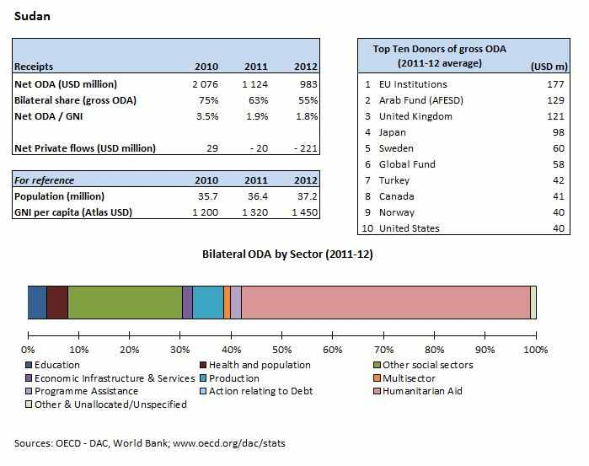

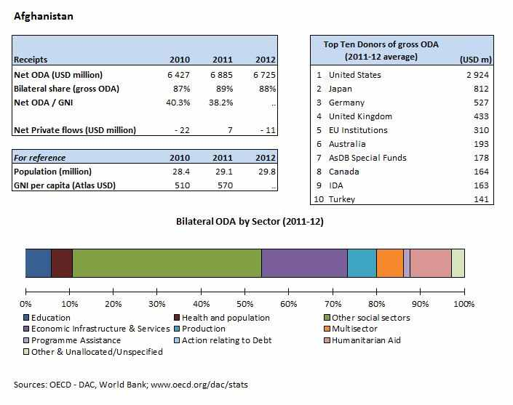

**IB Question**

• Compare and contrast the extent, nature and sources of ODA to two economically less developed countries.

**Syllabus item: 177 Weight: 5**

**Main idea 1**

• Arguments for and against aid

|  |  |
| --- | --- |
| For | Arguments |
| Emergency aid in times of disaster **saves lives**. | Aid can increase the **dependency** of LEDCs on donor countries. Sometimes aid is not a gift, but a loan, and poor countries may struggle to repay. |
| Aid helps **rebuild** livelihoods and housing after a disaster. | Aid may not reach the people who need it most. **Corruption** may lead to local politicians using aid for their own means or for political gain. |
| Provision of medical training, **medicines** and equipment can improve health and standards of living. | Aid can be used to put **political or economic pressure** on the receiving country. The country may end up owing a donor country or organization a favour. |
| Aid for **agriculture** can help increase food production and so improve the quality and quantity of food available. | Sometimes projects do not benefit **smaller farmers** and projects are often large scale. |
| Encouraging aid **industrial development** can create jobs and improve transport infrastructure. | Infrastructure projects may end up **benefiting employers** more than employees. |
| Aid can support countries in developing their **natural resources** and power supplies. | It may be a condition of the investment that the projects are run by **foreign companies** or that a proportion of the resources or profits will be sent abroad. |
| Projects that develop **clean water** and sanitation can lead to improved health and living standards. | Some development projects may lead to food and water **costing more**. |

**IB Question**

• Evaluate the effectiveness of foreign aid in contributing to economic development.

• Compare and contrast the roles of aid and trade in economic development.

**Main idea 1**

* International Monetary Fund (IMF)

- An international organization of 184 member countries

- Established to:

1) promote international monetary cooperation, 2) exchange rate stability and orderly exchange arrangements, 3) to foster economic growth and high levels of employment, and 4) to provide temporary financial assistance to countries to help ease balance of payments adjustment.

- It was set up to oversee currency values and act as a kind of 'credit union' from which national governments could obtain short term finance to overcome their balance of payments difficulties

- It has now developed into an 'international judge' of countries' economic policies - it offers loans conditional on the implementation of a prescribed set of free market policies.

**Syllabus item: 178 Weight: 3**

**4.6 The Roles of foreign aid and multilateral development assistance**

**- Multilateral development assistance**

**IB Question**

• Examine the current roles of the IMF and the World Bank in promoting economic development.

**Main idea 2**

• The World Bank

- Not a "bank" in the common sense. One of the United Nations' **specialized agencies**, and is made up of 184 member countries. (These countries are jointly responsible for how the institution is financed, and how its money is spent).

- It centers its efforts on reaching the Millennium Development Goals

^ The World Bank's role was concerned with financing reconstruction and development through the construction of national infrastructure such as roads and dams. By supporting projects through funding, and providing technical assistance, the World Bank considered that it would bring about increases in productivity, output and incomes and self-sustaining economic growth.

Together with other organizations provide low-interest loans, interest-free credit, and grants to developing countries as follows:

* The International Bank for Reconstruction and Development (IBRD)

This IBRD lends money at commercial interest rates to governments or private firms, guaranteed by their governments.

* The International Development Association

The IDA lends money, called credits, to the poorest countries on concessionary terms i.e. the repayment periods are longer than the IBRD's loans and the loans are interest free. These are called '*soft loans'*.

- **IFC is closely affiliated to the World Bank**. It was started up to enable funds to be lent to, or used to purchase shares in, private firms engaged in activities that would lead to development, but not needing a government guarantee.

- Up until the 1970s, much World Bank lending was targeted at projects primarily concerned with building energy and transportation infrastructure in developing economies

- Since the 1980s many World Bank loans have, like the IMF, been tied to certain strict conditions laid down in structural adjustment programmes.