4.1 Economic Development
Syllabus item: 164 Weight: 5
Section 4: Development economies
The nature of economic growth and economic development
164. Economic growth and economic development

Economic development

- A process where there is improvement in the lives of all people in the country
- Increase in economic growth does not necessarily mean economic development
Economic growth

- Rise in national income
- The value of all incomes in the economy added together
- GDP (Gross domestic product) is a common measure of national income

IB Question
• Explain the concept of price elasticity of demand, understanding that it involves responsiveness of quantity demanded to a change in price, along a given demand curve.
• Calculate PED using the following equation.
PED= percentage change in quantity demanded divided by percentage change in price
• State that the PED value is treated as if it were positive although its mathematical value is usually negative.

“Development as Freedom”
By Amartya Sen (1933-present), development economist

- Development is about increasing people’s freedoms
- Reducing poverty so that people can be adequately fed and sheltered
- Public provision of education, healthcare, and the maintenance of law and order
- The Guarantee of civil liberties and the opportunity for civic participation

IB Question
• Distinguish between economic growth and economic development.

Raising living standards
- Higher incomes
- Reduction in inequality
- Better housing
- Enhanced education
- Better health
Reducing widespread poverty
- Better living standards

Nature of economic development

Increasing employment opportunities
- Increase in both economic growth and development
Reducing income inequalities
- Poor people will get more money

IB Question
• Explain the multidimensional nature of economic development in terms of reducing widespread poverty, raising living standards, reducing income inequalities and increasing employment opportunities.

Most important sources of economic growth in economically less developed countries
Physical capital
- Directly productive capital - plant and equipment, e.g. factories
- Indirectly productive capital - infrastructure or facilitating capital, e.g. roads and railways

- Improving the quantity and quality of physical capital
- Quantity: affected by the level of saving, domestic investment, government involvement and foreign investment
- Quality: improved by higher education, research and development, and access to foreign technology and expertise
Human capital
- Improving the quantity and quality of labor
- Quality: improved by better health care, education for children, vocational training etc.
- HOWEVER, if the population grows at a faster rate than the level of GDP, the GDP per capita will fall

Technology
- Initiating technology
- Risk taking and innovation

IB Question
• Explain that the most important sources of economic growth in economically less developed countries include increases in quantities of physical capital and human capital, the development and use of new technologies that are appropriate to the conditions of the economically less developed countries, and institutional changes.

Institutional changes
- An adequate banking system
- A good education system
- Reasonable infrastructure
- Political stability
- Good international relationships
- A good health care

Q. Does economic growth lead to economic development?
Improvement in standard of living
…HOWEVER
There will be a significant group that will see little or no improvement
Increased government revenue
- Provision of essential services such as education, health care and infrastructure
Higher averages of economic indicators of welfare
- Average life expectancy
- Average years of schooling
- Improved literacy rate
…HOWEVER
This will not necessarily be the case for all sections of population

Positive
consequences!!
High economic growth

Negative
consequences!!

Negative externalities and lack of sustainability
- Pollution, deforestation, soil degradation and reduction in bio-diversity
- Demand for energy: Burning fossil fuels
- Huge emissions of CO2 leads to global warming
Creation of inequality
- Rich get richer, poor get poorer

Key words:
- Global warming
Severe effects on developing countries
- Insecure access to water
- Spread of tropical diseases
- Increased amount of drought and flood
- Risk to food security
- Rising sea levels
(Especially the coastal areas along with low-lying islands in the Caribbean Sea abd Pacific Ocean
- “Uneconomic growth”: Compromising the living standards of future generations

IB Question
• Explain the relationship between economic growth and economic development, noting that some limited economic development is possible in the absence of economic growth, but that over the long term economic growth is usually necessary for economic development (however, it should be understood that under certain circumstances economic growth may not lead to economic development).

165. Common Characteristics of economically less developed countries
Syllabus item: 165 Weight: 5
(Although it is dangerous to generalize as there are many exceptions in each case)
Country (Rank) | GDP per capita
Norway (3) | 65,640
Romania (60) | 16,518
Jordan (105) | 6,148
Liberia (177) | 655
Congo, Dem. Rep. (180) | 422
World Bank 2005-2012
(Romania developing country, thus exception)
- Low levels of GDP capita
Caused by:
- Low education standards
- Low levels of health among workers
- Lack of investment in physical capital
- Lack of access to technology

2. High levels of poverty
- Very low incomes
- High levels of inequality
- Very poor housing
- Poor health
- High infant mortality rates
- High levels of malnutrition
- Lack of education

3. Large urban informal sectors
- In many developing countries in Latin America, Sub-Saharan Africa, Middle East and Asia, the informal sector accounts for most of the total employment.
- E.g.) The informal sector in Indonesia in 2004 accounted for 64 per cent of the total employment.
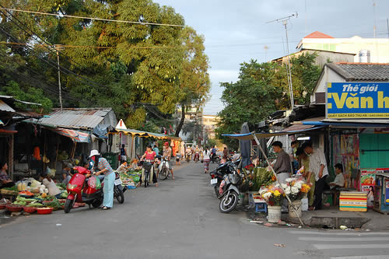

4. Relatively large agricultural sectors
- For the 70% of the world's poor who live in rural areas, agriculture is the main source of income and employment.
- However, depletion and degradation of land and water pose serious challenges to producing enough food and other agricultural products to sustain livelihoods in rural areas and to meet the needs of urban populations.

5. High (crude) birth rates
- Crude birth rates: annual number of live births per 1,000 of population
- The world average in 2005 20.15
- Niger:51.08 Mali: 46.09 (Developing countries)
- Austria: 8.65 Japan: 7.41 (Developed countries)
World Factbook 2010
- High crude rates tend to be transformed into high dependency ratios

Country (HDI rank) | Child dependency ratio (%) | Old age dependency ration (%)
Australia (2) | 28.1 | 20.7
France (8) | 28.4 | 26.2
UK(21) | 26.3 | 25.1
Bolivia (113) | 60.2 | 8.0
Botswana (125) | 52.1 | 6.1
Burkina Faso (177) | 90.0 | 3.9
Cambodia (137) | 51.0 | 5.6
Congo (176) | 91.0 | 5.2

IB Question
• Explain, using examples, that economically less developed countries share certain common characteristics (noting that it is dangerous to generalize as there are many exceptions in each case), including low levels of GDP per capita, high levels of poverty, relatively large agricultural sectors, large urban informal sectors and high birth rates.

Human Development Report 2009
Poverty cycle (Poverty trap)
- Seemingly endless continuation of poverty.
- To develop economically, countries need to invest in new and improved capital. However, investment needs funding and this requires savings. Countries with low income and low savings levels have a lack of funds for investment, which in turn leads to lower incomes.
- There is a need for invention to break out of the cycle

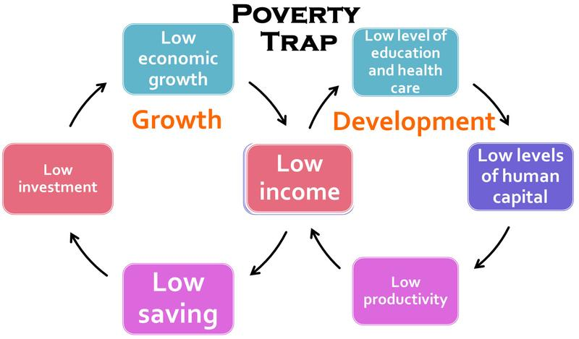

Examples of a poverty cycles

IB Question
• Explain that in some countries there may be communities caught in a poverty trap (poverty cycle) where poor communities are unable to invest in physical, human and natural capital due to low or no savings; poverty is therefore transmitted from generation to generation, and there is a need for intervention to break out of the cycle.

166. Diversity among economically less developed nations
Syllabus item: 166 Weight: 5

- Resource endowments
- Not all developing countries are poorly endowed
- Endowment in terms of physical resources can vary immensely between developing countries.

Key words:
- Endowments
- The resources they posses through nature
- E.g.) oil, natural gas, minerals etc.
Example

- Angola possesses oil and diamonds and yet is still very much a developing country

- Chad has been considered a country that lacked physical resources, but the discovery of oil and subsequent production since 2003 may make a large difference to the country

- Bangladesh, on the other hand, is very poorly endowed with the physical resources and synthetic products have now replaced the one major resource that they did have, jute

- Japan is not well endowed with physical resources and Singapore has almost literally none, yet both countries have created “economic miracles” over the last 50 years.

- Climate
- Climate varies widely among the developing countries.
- E.g.) in Russia, continental climate can be found and total precipitation is not very high whereas Egypt has a hot desert climate and generally dry.
- HOWEVER, it should be noted that most developed countries have temperate climates, while almost all developing countries have tropical and subtropical climates
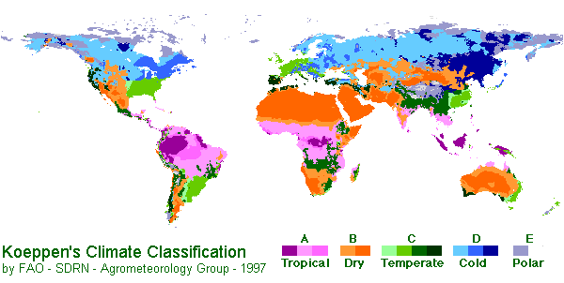
- A large proportion of developing countries were once colonies of developed countries
- Some countries gained some positive outcomes from colonization (e.g. Singapore and Hong Kong) and some did not (e.g. Vietnam and Angola)
- No matter developing countries we consider, there will be marked historical differences that will set the countries apart from each other socially, politically and economically
- History (Colonial or otherwise)

- Political systems
- Democracies, such as Brazil, Indonesia, and Mexico
- Monarchies, such as Brunei and Tonga
- Military rule, such as Myanmar and Pakistan
- Single party states, such as China, Cuba, and Syria
- Theocracies, such as Iran
- Transitional political systems, where a country is in transition, often caused by conflict and civil war, and so cannot be classified, such as Haiti and Somalia

- Degree of political stability

- Countries differ enormously with respect to their political stability
- A stable government is necessary for effective government decision-making and for implementing economic and other policies that have continuity over some years, creating a stable economic environment
- Political instability increases vulnerability to hunger and famine
E.g.) The 1948-85 famine in Ethiopia resulting in over 1 million deaths was caused as much by political instability, internal war and violence as by drought

IB Question
• Explain, using examples, that economically less developed countries differ enormously from each other in terms of a variety of factors, including resource endowments, climate, history (colonial or otherwise), political systems and degree of political stability.

167. International development goals
Syllabus item: 167 Weight: 5
- In 1970 the General Assembly of the United Nations made a commitment to the developing countries of the world that:
"Each economically advanced country will progressively increase its official development assistance to the developing countries and will exert its best efforts to reach a minimum net amount of 0.7 percent of its gross national product at market prices by the middle of the decade"

- The best known international development goals are the Millennium Development Goals (MDGs)
- The goals were adopted by world leaders in 2000, with the aim of them being achieved by 2015.

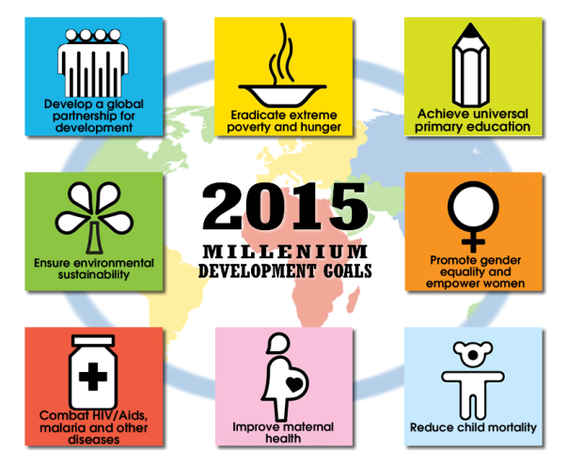
IB Question
• Outline the current status of international development goals, including the Millennium Development Goals.

