Webnote
342

Syllabus reference: 3.4: Economic Integration-comment

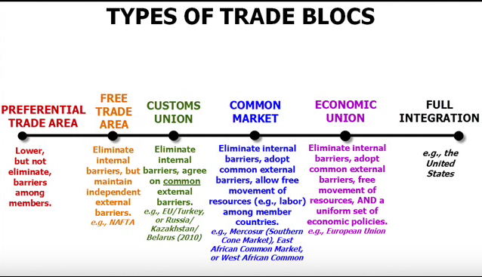
Economic Integration

Globalization-to make worldwide in scope or application

Free Trade Areas-(FTA’S)-an agreement in which to or more countries reduce trade barriers and tariffs among themselves. The free trade area does not try to set uniform tariffs for non-members.

Customs Union- an agreement in which two or more countries abolish tariffs and trade restrictions among themselves and adopt uniform tariffs for non-member countries.

EU
The most successful example of regional cooperation in the world today is the European Union (EU). The EU started out as a customs union. In January 1993, the EU became the single largest COMMON MARKET- in terms of population and output- on the world, although the US has since caught up in GNP. The EU is a single market because there are no internal barriers regulating the flow of workers, financial capital, or goods and services. Current members are 25 and include the original 15- Austria, Belgium, Denmark, Finland, France, Germany, Greece, Ireland, Italy, Luxembourg, Netherlands, Portugal, Spain, Sweden and the United Kingdom- plus ten new members in 2004-Cyprus, Czech Republic, Estonia, Hungary, Latvia, Lithuania, Malta, Poland, Slovakia and Slovenia. Bulgaria, Romania, Turkey and Croatia are up for membership in 2006.

ASEAN-another regional cooperation group is the Associations for Southeast Asian Nations. It is a ten nation group working to promote regional peace and stability, accelerate economic growth, and liberalize trade policies in order to become a free-trade area by 2008.

Economic Integration-For | Economic Integration -Against
Evaluate: | Evaluate:
- Lower (no) tariffs  therefore lower costs of production  - Larger markets:  -lager firms with economies of scale  -lower costs (AC)  -lower prices  -higher profits  -consumer, producer and society surplus increase  - Eu model very successful with a policy of common economic policies euro currency and common monetary policy  - Better access to economic aid and loan facilities e.g. Greek bailout  - Possible diagrams to use:  - Supply and demand to show fall in costs for firms= bigger markets  - Tariff reduction impact on costs and resulting in bigger markets  - LRAC to show economies of scale  - Consumer\producer/ society surplus diagram to show stakeholders winning from larger markets due to economic integration.  - Other? | - loss of sovereignty  - nations lose control of macroeconomy management e.g.  -ability to protect domestic industry  -this may result in unemployment in the domestic economy  - lose control of monetary policy (EU)  - Other

Adapted the Wilsonian era of Economic Thought

