Syllabus Reference 4. 4 : Exchange Rates: what influences an exchange rate?
Webnote 323
Syllabus weight = 3
Important definitions:

- Flexible exchange rate: Appreciation/depreciation
- Fixed exchange rate: Revaluation/devaluation
- Note also: Managed/dirty float/semi-fixed exchange rate/pegged system.

S3
Er 2
S2 (Supply Pound)
“Black
Wednesday”
S1
D pound
2.95 dm
Er 1
0
Fig 2: Exchange rate of Uk (sterling) priced in Deutschmarks
Er of
UK pound in DM
Quantity of Uk Pounds
(A) Exports:
X falls then ER falls. If X rises then ER increases.

(B)

Interest Rates: rates rise then demand for currency rises

(C)
Speculation
ERM
Soros
“black Wednesday”

(D)
Trade Flow:
X > M (surplus) or M > X
(deficit)

(E)
Inflation:

Domestic Inflation makes X more expensive.
Some Key influences on Exchange rates?
Fig 1: flow chart to show some key factors influencing exchange rates
George Soros http://www.georgesoros.com/
Syllabus weight = 3
Webnote 323
George Soros uses the wealth he amassed as a financier to support liberal U.S. political candidates and pro-democracy movements worldwide. As a teenage Hungarian immigrant at the London School of Economics, he studied finance and the "open society" theories of philosopher Karl Popper, an advocate of civil and political liberties. After brokerage work in London and New York, he started in 1969 what became the Quantum Fund, one of the world's first hedge funds. It eventually paid 4,000-fold on initial investments and made Soros a billionaire. His knack for seeing trends and acting on them with gutsy marketplace gambits sometimes caused controversy. He was called "the man who broke the Bank of England" for the role his currency trades played in the 1992 "Black Wednesday" crash of the British pound; in 2002 he was convicted of insider trading in France. He turned philanthropist in the 1970s through what is now an international network of foundations under the umbrella of the Open Society Institute. His first foray into U.S. presidential politics came in 2004, when he threw millions of personal dollars behind efforts to unseat George W. Bush. In 2007 he declared support for candidate Barack Obama.

Web links:
The STORY:
http://www.youtube.com/watch?v=AHDsO7gvXHQ&feature=related

http://www.youtube.com/watch?v=9bXNt1ec2FQ&feature=related

The SONG:
http://www.youtube.com/watch?v=uAA-kehYXm4

What was Black Wednesday?
- Soros borrowed 10B sterling from UK banks
- Soros bought US dollars with the 10B UK sterling
- Other speculators entered market and sold sterling and 50 billion sterling entered market shifting supply of the currency outside of the price band that the UK was committed to as a member of the ERM. The lowest value that the ERM agreed for sterling was a 2.95 DM value
- Soros bought sterling back some days later at a lower price and repaid 10 billion sterling to UK banks. Soros made a profit of 1 billion dollars.
- UK government to withdraw from the ERM where they were committed to a 2.95 dm minimum value. Soros’ actions pushed the value below this.
- What was the alternative for the UK and other ERM governments?
Two alternatives existed. One was to but the pound in vast quantities and take on the speculators but this would have required vast amonts of non sterling currencies. The second was to raise UK interest rates to encourage inflows of money into UK banks i.e. to buy sterling to avail of the rising interest rates. The third alternative was for the UK to withdraw from the ERM. The third alternative was the one taken and the UK has remained outside of the european currency reforms i.e. Euro

How do you draw Black Wednesday on an exchange rate diagram?

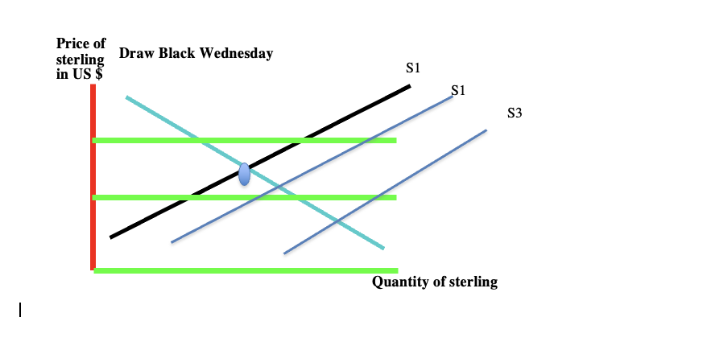

Variable/floating

- Definition
- Supply and demand determines exchange rate / price of the currency
2.What sets value ?
- S. Spending: imports and exports
- S. speculation
- S. capital transactions
3. How to adjust exchange rate?
- Adjustment is market based.
- If deficit on trade exists then Sc > Dc.
Therefore value of currency will fall making exports cheaper and imports more expensive. This will cause demand for currency to rise. i.e. self adjusting

4 Main advantage
- No government interference required to correct a high or low currency value.
5. Main disadvantage
Instability in exchange rates discourages trade: Businessmen hate
- uncertainty: next month’s the value of the currency?
- Instability: invest or not?
- Inflation: trade deficit brings likelihood of imported inflation

Note: Which is more suitable for LDC’S ? Fixed or Variable ?

Fixed/semi fixed/managed/dirty float

- Definition
One currency has a fixed value / price in terms of another
2.What sets value ?
- S. Spending: Imports result in an increase supply of domestic currency. Exports result in a demand for same
- S. Capital flows
- S. speculation
- BUT Government policy / government bank fixes value of currency and supports this by buying and selling on the currency markets and/or by using interest rates.
3. How to adjust exchange rate?
If currency falls below fixed rate then action must be taken to raise the value /price of the currency e.g.
- Open market operations i.e. government buys domestic currency
- Protectionism: keep imports out and put upward pressure on currency
- Attempt to stimulate export growth. Time lag a problem. Fiscal and monetary measures may be more effective in the short run. Export growth is the better alternative however

4.Main advantage

stability in Exchange rates brings stability in trade flows
5. Main disadvantage
- requires government intervention to maintain the desired fixed rate of exchange.
Note: Webnote 411 considers some alternative advantages and disadvantages of fixed and flexible exchange rates.

Webnote 323
Syllabus weight = 3
Syllabus Reference 4. 4 : Exchange Rates: fixed or variable?

