Dictionary – Section 3
Item Number | Term | Explanation | Diagram/Example
1 | Specialization | A method of production where a business or area focuses on the production of a limited scope of products or services in order to gain greater degrees of productive efficiency within the entire system of businesses or areas. Countries specialize in certain areas. | Germany specializes in machine building, especially in the automotive industry
2 | Division of Labour | The division of labour is a system whereby workers concentrate on performing a few tasks and then exchange their production for other goods and services.
3 | Free Trade | International trade taking place under market conditions without government intervention (with methods like Quotas or Tariffs)
4 | Embargo | This is a partial or complete ban on certain imports from a country. This is done usually in the form of political punishment. | - America has an Embargo on all Cuban goods  - Gaza by Israel and Egypt since 2001  -Georgia by Russia Commodites  - European Union Arms Embargoe on the People’s Republic of China
5 | Tariff | A tariff is a tax charged on imported goods. In this case, a higher price is paid by the importer to import these goods into the country. This is usually done in order to help the domestic industries boost their economic activity. | Implementing a tariff is basically implementing a tax on the world price. The world price goes up, and accordingly, Quantity demanded falls, and quantity supplied by domestic firms increases. Imported amount also decreases.  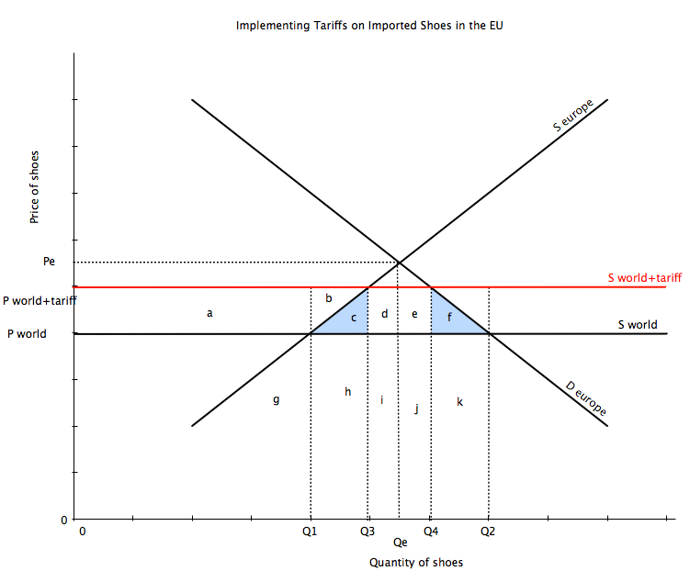
6 | Quota | A physical limit on the numbers or value of goods that can be imported into the country. | Without a quota, Q1 is being produced by domestic firms, and Q1-Q4 is being imported. When a quota is introduced, the quantity imported falls to a quota Q1-Q2. Now there is a shortage in the market because of excess demand. The price from then on keeps rising until a price is found, where everything in the market is stable again. At the new price P3, a quantity of Q2-Q3 is being imported (Quota) [this value of Q2-Q3 = Q1-Q2]. Now with a higher price, domestic producers come into the market, and hence the domestic supply shifts to the right to find a new equilibrium of demand and supply. (moves by value of quota).  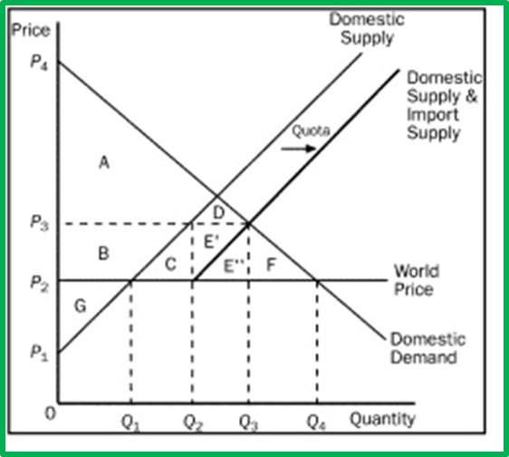
7 | Voluntary export restraint (VER) | A trade restriction on the quantity of a good that an exporting country is allowed to export to another country. This limit is self-imposed by the exporting country. Typically, VERs are a result of requests made by the importing country to provide a measure of protection for its domestic businesses that produce substitute goods. | When the automobile industry in the United States was threatened by the popularity of cheaper more fuel efficient Japanese cars, a 1981 voluntary restraint agreement limited the Japanese to exporting 1.68 million cars to the U.S. annually as stipulated by U.S Government
8 | Exchange controls | Types of controls that governments put in place to ban or restrict the amount of foreign currency or local currency that is allowed to be traded or purchased. | Zambia just recently dropped exchange regulations so that their currency was prevented from a decline. They have moved back to a free market form.
9 | Import licensing | Permit that allows an importer to bring in a specified quantity of certain goods during a specified period.  Import licenses are employed  (1) as means of restricting outflow of foreign currency to improve a country's balance of payments position  (2) to control entry of dangerous items such as explosives, firearms, and certain substances  (3) to protect the domestic industry from foreign competition.
10 | Administrative barriers | Countries are sometimes accused of using their various administrative rules (e.g. regarding food safety, environmental standards, electrical safety, etc.) as a way to introduce barriers to imports. | Example - Japanese video imports were to be inspected and pass customs in Poitiers in France (1981). Poiters is located inland, far away from ports with only a few officers. Delays led to the reduced imports of Japanese videos.
11 | Health and Safety standards | Restrictions may be in place based on the types of goods that enter the country or the methods of manufacturing involved. It is usually for the safety of the health of the population but some countries use it as an excuse to protect jobs | Gas Leak - Bhopal disaster in India, considered worlds worst industrial Disaster. 1984
12 | Environmental standards | Reason for ban on imports where the good is doing harm to the environment in the importing country or doesn’t meet its environmental standards. | Chinese Leather producing Chrome 6, which raises enviornmental issues in China and harms consumers with skin irritations in European countries
13 | Dumping | Dumping – Selling of large quantities of a commodity at a price lower than its production cost, in another country. | China was “caught” dumping solar panels in the EU in 2012. An agreement was reached between China and the EU on a quota of imports of solar panels.
14 | Infant Industry | An infant industry is a new industry, which in its early stages experiences relative difficulty or is absolutely incapable in competing with established competitors abroad. It has not yet achieved economies of scale and needs government support usually to achieve it. A lot of trade barriers are used to support these industries from external competition.
15 | Balance of Payments | Balance of payments account is a record of the value of all the transactions between the residents of one country and the residents of all other countries in the world over a given period of time.
16 | Exchange Rate | The price of a nation’s currency in terms of another currency. An exchange rate thus has two components, the domestic currency and a foreign currency, and can be quoted either directly or indirectly. | 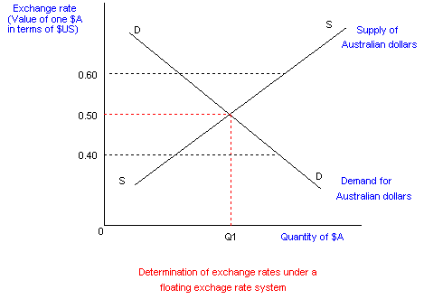
17 | Floating Exchange rate | Exchange rate regime where the value of a currency is to be determined solely by the demand and supply for the currency in a foreign exchange market. | Diagram above
18 | Fixed Exchange Rate | An exchange rate regime where the value of a currency is fixed to the value of another currency to the average value of a selection of currencies or to the value of a commodity (eg: gold) | 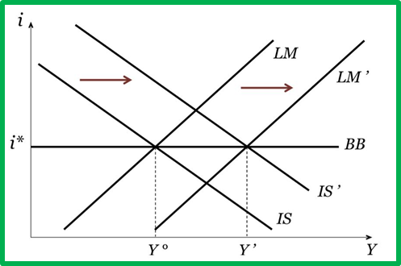  The value is pegged at BB. If supply of a currency increases, so will demand, and if the supply of a currency decreases, so will demand. The same is true for if demand of a currency increases/decreases.
19 | Managed Exchange Rate | Exchange rate is determined by the supply and demand of a currency with government intervention. No exchange rate regime is free floating and government intervention is often required to reduce uncertainty for businesses and for stability in the exchange rate. ERs fluctuate from day to day, but the central banks attempt to influence the ER so that it is stable.
20 | Dirty Float | Another word for Managed exchange rates.
21 | Trade Flow | Trade also called goods exchange economy is the transfer the ownership of goods from one person or entity to another by getting something in exchange from the buyer.
22 | Capital inflow + Interest rates | Capital inflow is a term for foreign money, which flows in more to earn more interest and take benefit of exchange rate variation. When interest rates in a country are high, then money will flow into the economy because foreigners will demand more of that currency and save it in the banks (with high interest rates). Currency will appreciate if there is a capital inflow.
23 | Exchange rates + Inflation | A country with a consistently lower inflation rate exhibits a rising currency value, as its purchasing power increases relative to other currencies.
24 | Currency speculation | The act of trading in an asset, or conducting a financial transaction, that has a significant risk of losing most or all of the initial outlay, in expectation of a substantial gain. With speculation, the risk of loss is more than offset by the possibility of a huge gain; otherwise, there would be very little motivation to speculate. This is dependent on a calculated risk.
25 | Foreign currency reserves | A foreign currency is held by central banks and other major financial institutions as a means to pay off international debt obligations, or to influence their domestic exchange rate.
26 | External Balance | A situation in which the money a country brings in from exports is roughly equal to the money it spends on imports.
27 | Currency Appreciation | An increase in the value of one currency in terms of another. Currencies appreciate against each other for various reasons, including capital inflows and the state of a country's current account. | 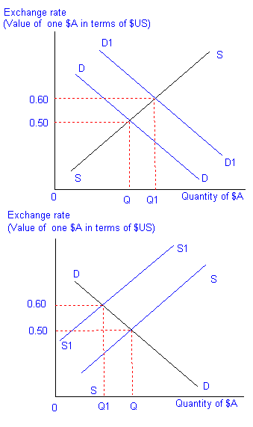
28 | Currency depreciation | A decrease in the level of a currency in a floating exchange rate system due to market forces. Currency depreciation can occur due to any number of reasons – economic fundamentals, interest rate differentials, political instability, risk aversion among investors and so on. | 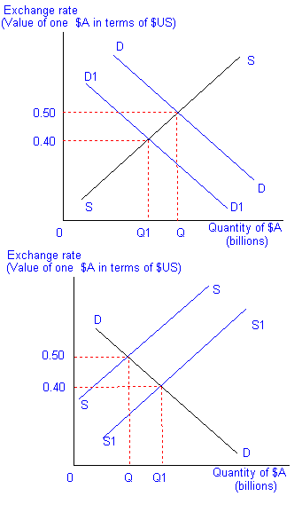
29 | Currency revaluation | Occurs in a fixed exchange rate regime. Here if the value of the currency is raised by the government/central bank, then it is called currency revaluation
30 | Currency devaluation | Occurs in a fixed exchange rate regime. Here if the value of the currency is decreased by the government, then it is called currency devaluation.
31 | Adjustable peg exchange rate system | An exchange rate policy adopted by some countries wherein the national currency is largely pegged or fixed to a major currency such as the U.S. dollar or euro, but can be readjusted from time to time within a narrow interval. | The Chinese renminbi or yuan was informally pegged to the US dollar in the mid-1990s until 2005 at a rate of approximately 8.28 per dollar. The peg was adjusted to about 6.83 yuan per U.S. dollar from July 2008, after three years of appreciation.
32 | Intervention buying/selling of a currency | Government intervenes in a foreign exchange market to influence the value of their currency. They may:  Lower ER to increase employment  Raise ER to fight inflation  Avoid large fluctuations in floating ER  Improve current account deficit  They do this by:  Buying or selling their own currency  Changing Interest rates
33 | Current Account | A measure of the flow of funds from trade in goods and services + other income flows.
34 | Balance of trade | This occurs when the revenue from exports = expenditure on imports.  Trade balance(goods) = Measure of the Revenue received from exports of tangible goods minus expenditure on imports of tangible goods over a period of time
35 | Invisible balance | Balance of trade in services is known as invisible balance. Trade balance (services) = measure of revenue received from exports of services – expenditure on the import of services. | Eg: Money coming in when a tourist travels in a country.
36 | Capital Account | Net change in ownership of national assets.  Capital account = FDI + Portfolio investment + Other investment + Reserve account.  Basically  Capital account = Change in foreign ownership of domestic assets minus change in domestic ownership of foreign assets.
37 | Import Substitution | This is the act of replacing foreign imports with domestic production of a certain good/service. This is done in order to boost the domestic industries.
38 | Economic Integration | Economic integration is the unification of economic policies between different states through the partial or full abolition of tariff and non-tariff restrictions on trade taking place among them prior to their integration.
39 | Current Account deficit | A measurement of a country’s trade in which the value of goods and services it imports exceeds the value of goods and services it exports. | Developed countries like the USA.
40 | Current account surplus | When the country’s export revenue > import expenditure.
41 | Expenditure reducing policies | Measures a government may undertake to improve an imbalance in the current account. If a nation has a large current account deficit, a decrease in spending on imports moves the current account towards surplus.  This will cause a decrease in aggregate demand.
42 | Expenditure switching policies | Government tends to switch the consumer’s purchase on foreign goods to domestic goods. | Implementation of protectionist policies on foreign goods.  Ex: Tariffs, Quotas.
43 | Capital account deficit/surplus | Deficit - An imbalance in a nation's balance of payments capital account in which payments made by the country for purchasing foreign assets exceed payments received by the country for selling domestic assets.  Surplus - An imbalance in a nation's balance of payments capital account in which payments received by the country for selling domestic assets exceed payments made by the country for purchasing foreign assets.
44 | Globalization | Increasing economic interdependence of national economies across the world through a rapid increase in cross-border movement of goods, service, technology, and capital
45 | Trading bloc | A group of countries that join together to form an agreement to increase trade between themselves or gain economic benefits from cooperation. | EU (European Union), AU (African Union), UNASUR (Union of South American Nations), CARICOM (Caribbean Community), NAFTA (North America Free Trade Agreement)
46 | Free Trade Area (FTA) | Agreement made between countries where they agree to trade freely amongst themselves, however they may choose to trade with countries outside this agreement however they may wish to.
47 | Customs union | Agreement made between countries to freely trade between themselves but put up trade barriers TOGETHER as a union against any country attempting to import into this customs union
48 | Common market | A customs union with common policies on product regulation and free movement of goods, services, capital and labour.

