Dictionary – Section 2 Macroeconomics
Item Number | Term | Explanation | Diagram/Example
1 | Macroeconomics | Field of economics that studies the behaviour of the aggregate economy. Unlike microeconomics, that deals with just the demand and supply of a firm, macroeconomics deals with the complete economy and examines changes in unemployment, national income, rate of growth, gross domestic product, inflation and overall price levels.
2 | National Income | Total amount of income earned by a country’s factors of production over a given period of time, no matter where the assets are located.
3 | Closed Economy | An economy in which no activity is conducted with the outside economies. It is self-sufficient, wherein, no exports or imports (trade) are/is conducted with other countries.
4 | Open Economy | Economy in which there are economic activities between domestic community and outside. Trade is conducted and imports and exports are allowed. | Business with people, businesses
5 | Circular Flow of Income | Flow of income and expenditure between consumers and firms. Firms provide income to households in exchange for f.o.p that is provided by households. Households then buy goods and services using this income from firms, and that’s how the income keeps flowing. The government can control this flow by INJECTING and LEAKING income. (Discussed ahead and detailed diagram given in item 78) | 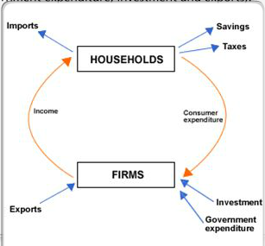
6 | Expenditure flow | Consumer expenditure on goods and services provided by firms. This could also mean government expenditure into the economy to improve conditions in the economy.
7 | Value of output flow | Input flow = Output flow. In other words, this refers to ways of measuring income, where Income of a firm, for example is basically equal to the expenditure of the firm.
8 | Income | Economic wealth that is generated in exchange for an individual's performance of agreed upon activities or through investing capital.
9 | Wealth | A measure of the value of all of the assets of worth owned by a person, community, company or country
10 | Growth | Item in Section 4/1 Dictionary
11 | Injection | Additions into the circular flow of income. Three main injections are Investment (I), Exports (X) and Government Expenditure (G). This is a way of filling in money into the circular flow of income so as to expand it.
12 | Leakage | Flows of money that leave the circular flow of income. Income that is not passed on by consumer. 3 main leakages are Savings (S), Taxes (T) and Imports (M).
13 | GDP | Measure of the level of economic activity within a country regardless of who owns the assets. It is the total value of all goods and services produced over a given time period. It is a indicator of measuring growth of an economy
14 | Green GDP | Measure of GDP considering the environmental costs that are caused due to economic activity conducted by firms in the country.  Green GDP = GDP + Environmental costs of production
15 | GNI | Total income that is earned by a country’s factors of production no matter where the assets are located.  GNI = GDP + Income from assets abroad - income paid to foreign assets in the country is known as net property income from abroad.  GNI = GDP + net property from abroad
16 | GNP | Market value of all the products and services produced in one year by labor and property supplied by the residents of a country
17 | National Income at Market Prices | Total primary income receivable by resident institutional units: compensation of employees, taxes on production and imports less subsidies, property income (receivable less payable), (gross or net) operating surplus and (gross or net) mixed income.
18 | Nominal National Income/Output | National Income is the same as National output, as they are just two different ways of measuring income flows (with reference to circular flow diagram item).  Nominal National Income is the value of national product or factor incomes calculated under current prices that includes inflation.
19 | Real National income/output | Nominal income or output adjusted for inflation. Measuring the value of output or income with inflation doesn’t help, and hence, the value of inflation needs to be eliminated, to give a clear picture of whether or not a country has grown or not.
20 | GDP Deflator | An economic metric that accounts for inflation by converting output measured at current prices into constant-dollar GDP. The GDP deflator shows how much a change in the base year's GDP relies upon changes in the price level.
21 | Per Capita Income | Income earned per person. Simply it is the National income of the economy (aggregate) divided by the population.
22 | National Income statistics | A “report card” where all the values and data regarding a country’s national income is recorded.
23 | LDC (Less Developed Country) | A country designated by the UN as LDC based on criteria of low per capita GDP, weak human resources (life expectancy, calorie intake, etc.), and a low level of economic diversification (share of manufacturing and other measures). | Africa
24 | MDC (More Developed Country) | Sovereign state that has a highly developed economy and advanced technological infrastructure relative to other less developed nations. Also known as a developed country. | USA, Norway, Germany
25 | Business Cycle | Economy-wide fluctuations in production, trade and economic activity in general over several months or years in an economy organized on free-enterprise principles.  Periodic fluctuations in economic activity measured by changes in real GDP  Phases of the business cycle include boom, recession, trough and recovery. | 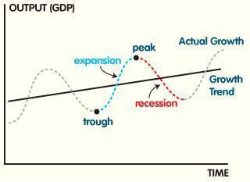
26 | Macroeconomics Model | Analytical tool designed to describe the operation of the economy of a country or a region
 |  | Section 2.2
27 | Aggregate Demand | The total spending on goods and services in a period of time at a given price level. Unlike microeconomics, which focusses on demand for a product in one specific market, aggregate demand is the demand of multiple markets in the economy. | 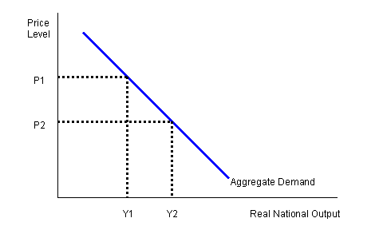
28 | Aggregate Supply | Total amount of goods and services all the industries in the economy will produce at every given price level. | 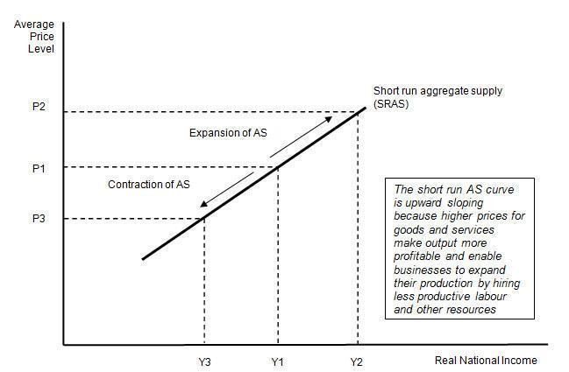
29 | SRAS (Short-run Aggregate Supply) | Short run: Period of time when the factors of production do not change  - If output needs to be increased, then costs of production are higher and hence prices will rise
30 | LRAS (Long-run Aggregate Supply) | Two models to express the situation in the long run. One is the new classical (monetarist) AS model and the other is the Keynesian AS model. (Diagrams are given below)
31 | Keynesian LRAS | This model has 3 phases, where:  Phase 1: AS is perfectly elastic at low levels of economic activity. Producers can increase their output at average costs, by using under/un-used capital and labour (Spare capacity). They can be used at full capacity without increasing production costs (or raising prices)  Phase 2: Economy’s available factors become scarce at one point in time as capital and labour tend to get used up, and prices of f.o.p increase, thus pushing up the price (due to higher costs for producers)  Phase 3: When full capacity is reached, then output level is max as all f.o.p are being used and hence keep the price rising without changing output. | 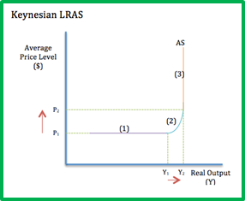
32 | Monetarist LRAS | The model shows full inelasticity where output level is max, and it represents the potential output of the economy operating at full capacity with “zero” unemployment. No matter what the price is, other than a shift in the entire curve, there will be a fixed output level known as full employment level of output | 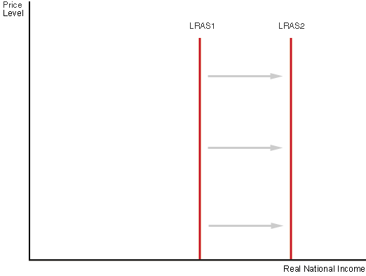
33 | Supply Shock | An event that suddenly changes the price of a commodity or service. It may be caused by a sudden increase or decrease in the supply of a particular good. It affects the equilibrium price.  Negative supply shock causes an increase in price and a movement towards the left of the supply curve.  A positive supply shock causes a decrease in price and a movement towards the right of the supply curve. | 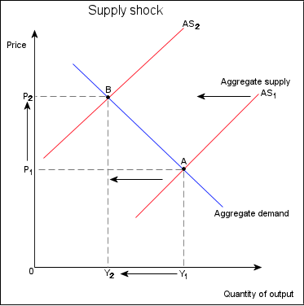
34 | Keynesian economics | The view that in the short run, especially during recessions, economic output is strongly influenced by aggregate demand (total spending in the economy). In the Keynesian view, aggregate demand does not necessarily equal the productive capacity of the economy; instead, it is influenced by a host of factors and sometimes behaves erratically, affecting production, employment, and inflation.
35 | Milton Friedman School | Milton Friedman put forth an idea of using free market principles to improve the United States public school system. Typically, public schools are funded by state and local taxes, and children are assigned a public school based on where their parents live. Friedman proposed that parents should be able to receive those education funds in the form of vouchers, which would allow them to choose their children's schools, including both public and private, religious and non-religious options.
36 | Monetarism | School of economic thought that emphasizes the role of governments in controlling the amount of money in circulation. It is the view within monetary economics that variation in the money supply has major influences on national output in the short run and the price level over longer periods and that objectives of monetary policy are best met by targeting the growth rate of the money supply.
37 | Equilibrium National Income | National Income = National Output (as seen before and in items from 2.1). Equilbrium National income/Output is where the Aggregate supply is equal to the Aggregate Demand.
38 | Full Employment National Income | As used by the two models, Full employment national income/output is basically the fact that the output is max when there is zero employment and all f.o.p are used at full capacity. This is used in the LRAS monetarist model.
39 | Inflationary Gap | LRAS monetarist model - Economy is in equilibrium at a level of output > than full employment level of output. Distance between Yp and Y1 is the inflationary gap.  LRAS Keynesian model - Level of AD in the economy cannot be satisfied given the existing resources. As a result, price level rises to allocate the scarce resources among the competing components of AD (consumers, producers and govt.)  Diagram – AD3 and AD4 onwards, there is an inflationary gap | 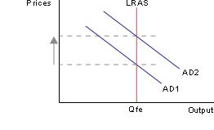  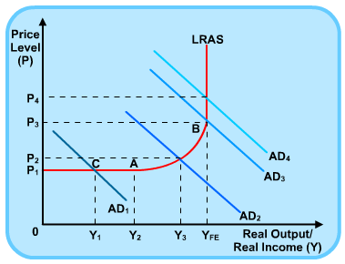
40 | Deflationary Gap | LRAS Monetarist Model - Economy is in equilibrium at a level of output < than the full employment level of output.  Equilibrium at P₀ moves to equilibrium at P₁ as AD decreases, hence in the short run, the output would decrease. Therefore, output will be less than full employment output. The costs of production will decrease and hence SRAS with equilibrium of price P₀ moves to price of P₂ and full employment output has been achieved.  LRAS Keynesian Model - Level of AD in the economy is not sufficient to buy up the potential output that could be produced by the economy at a full employment level of output | 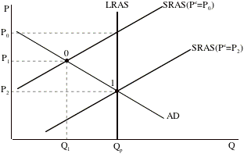  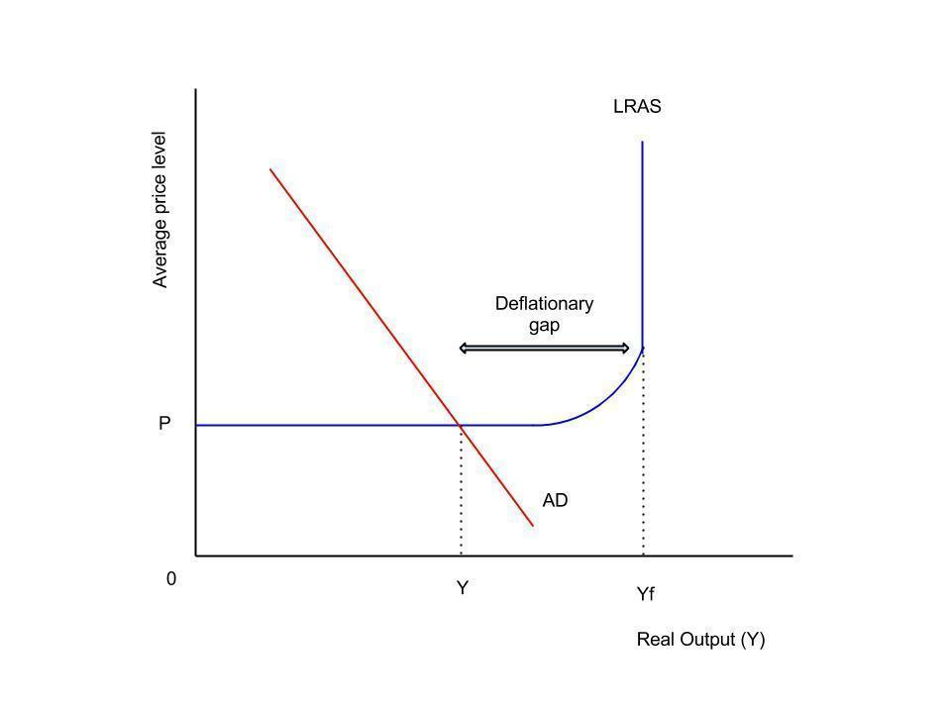
 |  | Section 2.3
41 | Full Employment | A situation where all labour resources are being used in the most economically efficient way. This embodies the highest amount of skilled and unskilled labour that can be employed within an economy at any given time. All that are willing and able to work are working.
42 | Full Employment Output | The quantity of real production or real aggregate output produced by the macroeconomy when all resources are at full employment. For practical purposes, it is the real GDP produced when unemployment is at its natural level. For the aggregate market analysis, this is the level of real production achieved and maintained in the long run.
43 | Underemployment | A measure of employment and labour utilization in an economy that looks at how well the labour force is being utilized in terms of skills, experience and availability to work. | People maybe highly skilled by underpaid, highly skilled but working in low skilled jobs, and part time workers that prefer working full time or can work full time.
44 | Natural or Equilibrium rate of unemployment | The rate of unemployment where real wages have found their free market level. It is where the aggregate supply of labour is in balance with the aggregate demand for labour. It consists of frictional and structural unemployment. | In this diagram at the real wage rate W1, E1 workers are employed. But at this prevailing wage rate, the total labour force exceeds than the employed labour force.  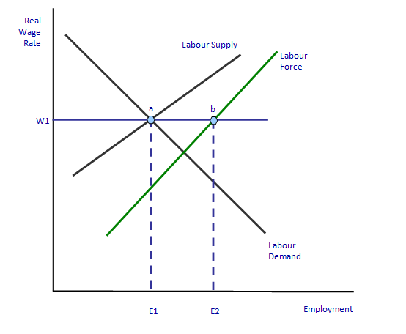
45 | Structural Unemployment | Occurs due to a change in the structure of the economy. There is a permanent fall in demand for a particular type of labour. | For example, the newspaper industry has been in decline since 2000, as web-based advertising has taken over its source of revenue. Employees, such as journalists, printers and newspaper delivery boys, who were dependent upon that industry, contribute to structural unemployment after they've been laid off. Since their skills were narrowly focused on the newspaper's method of distributing news, they have a harder time getting a different job unless they are retrained.
46 | Seasonal Unemployment | Demand for certain workers falls during certain times of the year | Demand for construction workers may fall during the winter, ski instructors won’t be required in the summers
47 | Classical/Real wage unemployment | This is caused by labour unions and government, setting wage rates above the equilibrium resulting in a higher supply of labour.
48 | Disequilibrium Unemployment | This occurs where imperfections in the labour market prevent it from reaching the full employment level of output. | Same diagram as above. Disequilibrium caused due to a fixed rate on wages.
49 | Inflation | Inflation is defined as the steady increase in the average level of prices of goods and services in an economy. An acceptable rate of inflation is 2% because it shows that an economy is growing. 0% inflation is not something countries wish for because it is not healthy for the economy. The good inflation is demand pull inflation because it results in an increase in GDP but cost push inflation is bad because it results in a decrease in GDP.
50 | Core Inflation | A measure of inflation that excludes certain items that face volatile price movements. Core inflation eliminates products that can have temporary price shocks because these shocks can diverge from the overall trend of inflation and give a false measure of inflation.
51 | Underlying Inflation | A calculated measure that takes the headline inflation rate and excludes certain volatile items or series that are affected by factors other than general economic conditions. | For example heavy fluctuating economic goods, such as oil and commodities
52 | Retail or consumer price index | Consumer price index is the official measure of inflation of consumer prices. Retail price index is the measure of inflation published monthly by the Office for national statistics. It measures the change in costs of a basket of retail goods and services.
53 | Anticipated Inflation | The percentage increase in the level of prices over a given period that is expected by participants in an economy. | For example, the level of anticipated inflation can affect how an individual invests their savings, how a business sets its prices, and the interest rates at which banks lend money.
54 | Unanticipated Inflation | When it is difficult to predict what the rate of inflation will be in the near future. This happens when the rate of inflation becomes unstable or easily changeable from time to time. Thus, people, business, or government makes error in predicting inflation.
55 | Hyperinflation | Extremely rapid or out of control inflation. Here the prices increases are so out of control that inflation is meaningless. Money loses its value and purchasing power rapidly decreases. It often occurs when there is excess supply of money in an economy not supported by GDP | Zimbabwe is a country that is facing Hyperinflation. Germany also faced hyperinflation in the 90s.
56 | CPI | Item 52 of this dictionary
57 | PPI | Measures the average changes in prices received by domestic producers for their output.
58 | Weighted Price Index | A stock index in which each stock influences the index in proportion to its price per share. The value of the index is generated by adding the prices of each of the stocks in the index and dividing them by the total number of stocks. Stocks with a higher price will be given more weight and, therefore, will have a greater influence over the performance of the index.
59 | Deflation | This is where there is a steady decline in prices of goods and services in an economy caused usually by the reduction in the supply of money or credit. Deflation can be caused also by a decrease in spending of an economy. This in turn could lead to high amounts of unemployment because firms end up laying off workers. This in turn could lead to economic depression.
60 | Disinflation | This is a decrease in the rate of inflation.
61 | Cost push inflation | Cost push inflation occurs when there is an increase in prices of an economy due to a rise in costs of production. It is also known as bad inflation because of the fact that it causes a decrease in real output. | This inflation causes a shift in aggregate supply of an economy inwards, resulting in an increase in prices and at the same time, a decrease in real output /GDP of an economy.  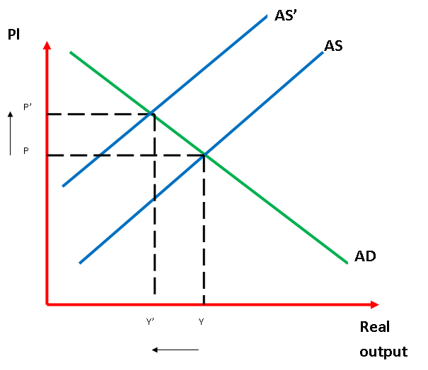
62 | Demand pull inflation | This inflation is caused by an increased aggregate demand in an economy. People of the economy increase their spending in the economy which results in demand pull inflation. It is known as good inflation because of the fact that it causes an increase in real output. | This inflation causes an outward movement of the AD curve resulting in an increase in prices but at the same time an increase in real output/GDP of an economy.  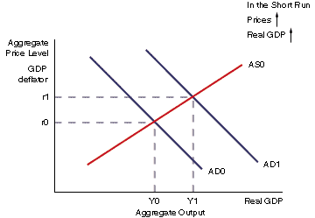
63 | Productivity | An economic measure of output per unit of input. Inputs include labor and capital, while output is typically measured in revenues and other GDP components such as business inventories.
64 | Physical Capital | Physical capital refers to any manufactured asset that is applied production, such as machinery, buildings, or vehicles, which is one of the three primary factors of production (the other two are land and labor/workforce). In general physical capital refers to any non-human asset made by humans and then used in production.
65 | Human Capital | A measure of the economic value of an employee's skill set. This measure builds on the basic production input of labor measure where all labor is thought to be equal. The concept of human capital recognizes that not all labor is equal and that the quality of employees can be improved by investing in them.
66 | Natural Capital | A reference to the stock of natural resources, such as water and oil. Unlike other forms of equity (such as machines and buildings), which can be created on a regular basis, many natural resources are nonrenewable. In economics, depletion of natural resources is a consequence that needs to be accounted for when looking at a company's effect on total welfare.
67 | Absolute Poverty | Lack of sufficient resources required in order to sustain and survive  People in absolute poverty struggle to meet their basic needs
68 | Relative Poverty | Income or resources in relation to the average within a country  Living standards of these people are well below an observed “average” in the economy.
69 | Lorenz Curve | Curve used to measure the income inequality in an economy. It is the curved line in the graph that indicates the existence of unequal distribution of income in an economy.  X-axis = cumulative % of total population  Y-axis = cumulative % of total income | 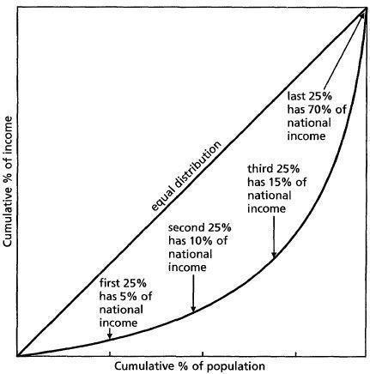
70 | Gini Coefficient | Ratio of the area between the line of equality and a country’s Lorenz curve to the total area under the line of equality. Higher this index, the higher the income inequality.
71 | Decile | A decile is any of the nine values that divide the sorted data into ten equal parts, so that each part represents 1/10 of the sample or population. A decile is one possible form of a quantile.
72 | Quintile | Any of five equal groups into which a population can be divided according to the distribution of values of a particular variable. 1/5 = quintile
 |  | Section 2.4
73 | Transfer Payments | One-way payment of money for which no money, good, or service is received in exchange. It is used by governments as a means of redistributing income in the economy. | social welfare programs such as social security, old age or disability pensions, student grants, unemployment compensation
74 | Budget Deficit | If government spending is greater than the government income/revenue, then it causes a budget deficit | In January 2014, the US budget deficit fell down by 37%, from $290.41billion to $184.02 billion. This was because government spending fell by 3% in the last quarter of 2013 and government revenue climbed by 8%.  Ref - http://goo.gl/vktbyT
75 | Budget Surplus | If government revenue/income is greater than the government spending then it causes a budget surplus. | Greece had a budget surplus during the year of 2013, which according to the government was double the amount they had predicted.
76 | Balanced Budget | If government spending is equal to government income/revenue, then there is a balanced budget.
77 | Expansionary fiscal policy | This is employed when the economy is in a recession or a downturn. It is used to boost economic activity, and increase AD in the economy. Measures include lowering taxes, increasing government spending, and lowering interest rates. For classical economists, this may result in demand pull inflation and for Keynesian economists, it will only create demand pull inflation when all spare capacity has been used up. It is also known as Reflationary fiscal policy. | Classical Economists:  Keynesian economists  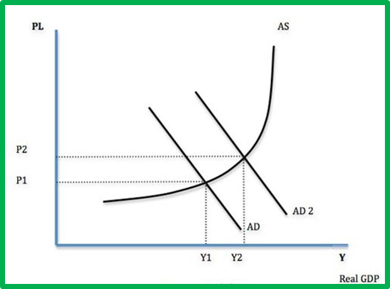
78 | Contractionary fiscal policy | This is employed when the economy is producing beyond its capacity thus causing problems like inflation and balance of payments problems. Measures include increasing taxes, lowering government spending and increasing interest rates. Both economists agree that this could result in deflation which is why it is also known as a deflationary fiscal policy.
79 | Automatic tax stabilizer | Automatic stabilizers are used to dampen the business cycle so as to prevent and reduce short-term fluctuations. If a country’s real GDP is increasing then so will incomes. If there is a progressive tax system, like an income tax, then this would mean higher revenue for the government = leakage for the economy. Economy automatically stabilizes.
80 | Crowding out | An economic concept where increased public sector spending replaces, or drives down, private sector spending. Crowding out refers to when government must finance its spending with taxes and/or with deficit spending, leaving businesses with less money and effectively "crowding them out." | The higher taxes required for government to fund social welfare programs leaves less discretionary income for individuals and businesses to make charitable donations. Further, when government funds certain activities there is little incentive for businesses and individuals to spend on those same things. Another example is increased government spending on Medicaid, which has been linked to decreased availability of private health insurance.
81 | Time lag | The delay between economic action and economic consequence. | For example, changing interest rates, there will be a time lag involved because some consumers may have a fixed mortgage for 2 years and interest rates for them will be fixed for that time. Hence time lag involved.
 |  | Section 2.5
82 | Monetary policy | The actions of a central bank, currency board or other regulatory committee that determine the size and rate of growth of the money supply, which in turn affects interest rates. This is maintained by changing interest rates and changing the amount of money banks need to keep in reserves.
83 | Interest rate | It is known as the price of money determined in a “money market” where demand and supply of money meet at equilibrium. | 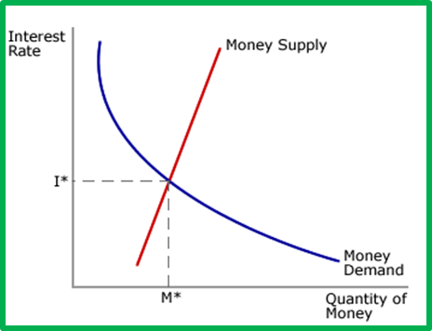
 |  | Section 2.6
84 | Supply side policy | These are government economic policies that change aggregate supply to bring stability in an economy. These may be market based or interventionist policies.
85 | Market based supply side policy | 1. Deregulation – remove barriers in the market to allow competition.  2. Privatization – selling of state owned enterprises to the private sector  3. Increasing incentives to work like lower direct taxation and reducing unemployment benefits – increase productivity.  4. Cutting government spending and taxes and policies to cut government borrowing.  5. Opening up overseas trade and agreement
86 | Interventionist based supply side policy | 1. Improve Infrastructure  2. Tax incentives and welfare reforms can encourage more people into work  3. Fair minimum wages  4. Nationalization of industries  5. Management of exchange rates to improve competitiveness of export industries.
87 | Laffer Curve | It is a graph that represents the relationship between tax rates and tax revenue collected by governments. | The curve suggests that, as taxes increase from low levels, tax revenue collected by the government also increases. It also shows that tax rates increasing after a certain point (T*) would cause people not to work as hard or not at all, thereby reducing tax revenue. Eventually, if tax rates reached 100% (the far right of the curve), then all people would choose not to work because everything they earned would go to the government.