* 1. Elasticity

**Syllabus item: 18 Weight: 3**

**Section 1: Microeconomics**

**Price Elasticity of Demand (PED)**

1. *Price Elasticity of Demand and its determinants*

***Elasticity***

* Measure of responsiveness. It measures how much something changes when there is a change in one of the factors that determines it.
* **Elasticity of demand**
* **Elasticity of supply**

***Price elasticity of demand***

* A measure of the responsiveness of the demand for a product to changes in its own price.
* Elasticity rages from **zero** to **infinity** and the value is given different names over different numerical changes.

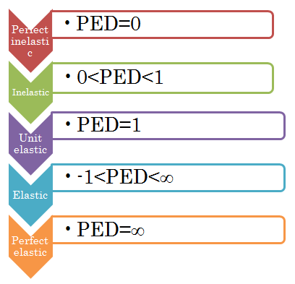

**Formula**

% change in Qd of the product

% change in price of the product

PED=

Example

A publishing firm decreases its magazine price:

Calculation

1. % change in price

-50 (cent) /500 (cent) × 100 = -10 %

1. % change in quantity

30000/200000 × 100 = 15 %

1. PED= 15%/-10% = **-1.5**

|  |  |
| --- | --- |
| P ($) | Qd |
| 5  -50 cent | 200000  +200000 |
| 4.5 | 230000 |



The negative value indicates that there is an inverse relationship between P. and Qd.

**HOWEVER…**

Economists usually ignore the negative value that comes from the equation and simply give the answer as a positive figure:

**Answer: 1.5**

**IB Question**

• Explain the concept of price elasticity of demand, understanding that it involves responsiveness of quantity demanded to a change in price, along a given demand curve.

• Calculate PED using the following equation.

***PED= percentage change in quantity demanded divided by percentage change in price***

• State that the PED value is treated as if it were positive although its mathematical value is usually negative.

1. **Perfectly inelastic demand**

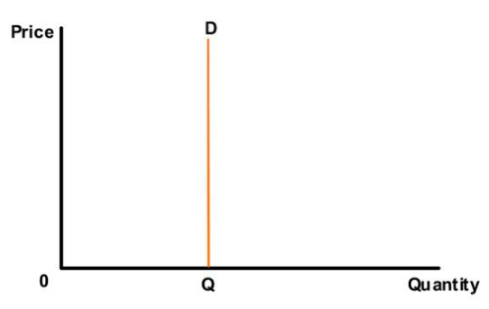

* PED = 0
* Meaning that price has no effect on demand at all.
* A change in price will mean that demand remains exactly the same

(Vertical demand curve)

1. **Inelastic demand**

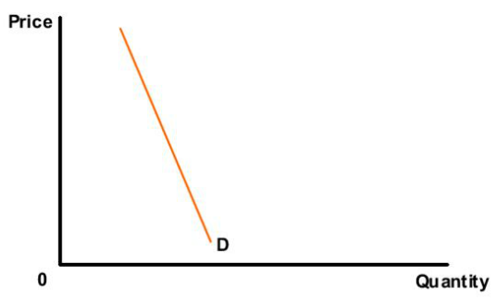

* 0 <PED <1
* Meaning % change in price is larger than the % change in demand
* Any change in price will result in a relatively smaller change in quantity demanded

(Relatively steep demand curve)

1. **Unit elastic demand**

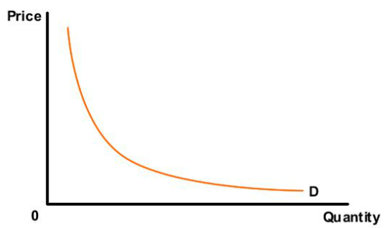

* PED = 1
* Meaning % change in price is identical to the % change in quantity demanded. (proportional)
* Any change in price will result in the same change in quantity demanded

(Rectangular hyperbola demand curve)

1. **Elastic demand**

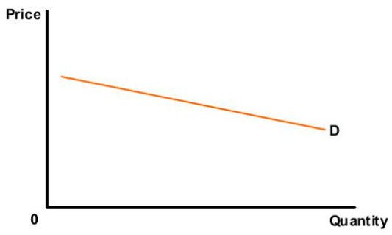

* -1< PED <∞
* Meaning % change in price is less than the % change in demand
* A change in any price will result in a larger change in quantity demanded

(Relatively flat demand curve)

* **Goods with elastic demand are more responsive to price changes**

1. **Perfectly elastic demand curve**

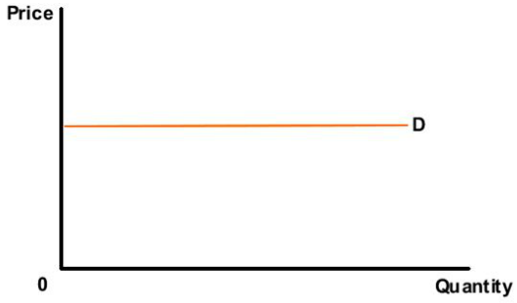

* PED = ∞
* Meaning an infinite amount is demanded at one price but nothing at all at a slightly higher price
* There is an infinite demand at one price level, but any other price levels, nothing will be demanded

(Horizontal demand curve)

**IB Question**

* Explain, using diagrams and PED values, the concepts of price elastic demand, price inelastic demand, unit elastic demand, perfectly elastic demand and perfectly inelastic demand.

***Determinants of PED***

* The value of price elasticity of demand for a good depends on a number of factors.

1. **The number and closeness of substitutes**

* The more substitutes there are for a product, the more elastic will be the demand for it. Also, the closer the substitutes available, the more elastic will be the demand.

Example

C:\Users\Mayu\AppData\Local\Microsoft\Windows\Temporary Internet Files\Content.IE5\Z7X98BNC\MC900326690[1].wmf

C:\Users\Mayu\AppData\Local\Microsoft\Windows\Temporary Internet Files\Content.IE5\4CJ9U9B7\MC900287189[1].wmf

**PRICE UP**

**PRICE UP**

D

D

D

D

C:\Users\Mayu\AppData\Local\Microsoft\Windows\Temporary Internet Files\Content.IE5\AOVMW2E4\MC900326640[1].wmf

C:\Users\Mayu\AppData\Local\Microsoft\Windows\Temporary Internet Files\Content.IE5\AOVMW2E4\MC900325316[1].wmf

C:\Users\Mayu\AppData\Local\Microsoft\Windows\Temporary Internet Files\Content.IE5\Z7X98BNC\MC900407822[1].wmf

D

D

C:\Users\Mayu\AppData\Local\Microsoft\Windows\Temporary Internet Files\Content.IE5\Z7X98BNC\MC900384332[1].wmf

D

D

C:\Users\Mayu\AppData\Local\Microsoft\Windows\Temporary Internet Files\Content.IE5\SMU9TW5A\MC900251607[1].wmf

More substitutes

If the price of one rises, consumers can easily switch to other types of jam.

* **Elastic demand**

Fewer substitutes

There are only few substitutes for petrol. When the price of petrol rises, there is not a significant drop in demand.

* **Inelastic demand**

1. **The degree of necessity**

* Goods considered ‘essential’ by consumers will have inelastic demand

Etc.

Non-essential

Essential

*For many goods necessity will change from consumer to consumer, since different people have different tastes and necessity is often a subjective view

1. **Time period**

People do not have many alternatives to switch to

* In the short run, goods have inelastic demand whereas in the long term, demand is more elastic.

Example

Short term 🡪 price rise in heating oil 🡪 Demand relatively inelastic

Long term 🡪 still high price of heating oil 🡪 Demand elastic

Consumers have time to change their heat systems to ones that uses gas, coal or wood.

1. **Proportion of income spent on goods**

* Cheap items likely to have an inelastic demand and for larger items of expenditure, the consumer will be more inclined to weigh up the purchase more carefully, so it is elastic demand.





C:\Users\Mayu\AppData\Local\Microsoft\Windows\Temporary Internet Files\Content.IE5\AOVMW2E4\MC900426062[1].wmf

C:\Users\Mayu\AppData\Local\Microsoft\Windows\Temporary Internet Files\Content.IE5\AOVMW2E4\MC900405982[1].wmf

C:\Users\Mayu\AppData\Local\Microsoft\Windows\Temporary Internet Files\Content.IE5\SMU9TW5A\MC900349011[1].wmf

Inelastic

Elastic

**Key word:**

* **Expenditure**
* 1. the total amount of money that a government, organization, or person spends during a particular period of time
* 2. the action of spending or using time, money, energy etc:

**IB Question**

• Explain the determinants of PED, including the number and closeness of substitutes, the degree of necessity, time and the proportion of income spent on the good.

* **Calculating PED between 2 designated points on a demand curve using PED equation**

**Calculation**

**Point A to B**

* Price $20 🡪$18

PED = 10/3 ÷ 10 = **3.3**

**Point C to D**

* Price $10 🡪 $8

PED = 25/2 ÷ 20 = **0.625**

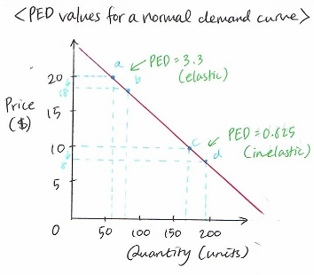

* **The PED value is NOT the same at any point on the curve.**
* The value of PED **falls** as we move down the demand curve.
* **The graph suggests that low-priced products have a more inelastic demand than high-priced product**

**Why?**

* Because consumers are less concerned when the price of an inexpensive products rises than they are when the price of an expensive product rises.

**IB Question**

* Calculate PED between two designated points on a demand curve using the PED equation above.
* Explain why PED varies along a straight line demand curve and is not represented by the slope of the demand curve.

**IB Question**

* Explain the negative causal relationship between price and quantity demanded.
* Describe the relationship

between an individual

consumer’s demand and market demand.

*19. Applications of price elasticity of demand*

**Syllabus item: 19 Weight: 4**

***Price elasticity and firms***

* It would be useful for the firm to know what effect a particular price change might have on total revenue.

Example

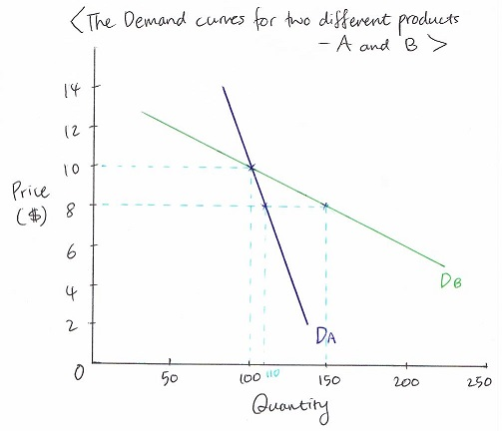

Db = elastic

Da = inelastic

Product B (elastic)

Product A (inelastic)

|  |  |  |
| --- | --- | --- |
| Price ($) | Qd | TR (total revenue: $) |
| 10 | 100 | 10 × 100 = 1000 |
| 8 | 110 | 8 × 150 = 1200 |

|  |  |  |
| --- | --- | --- |
| Price ($) | Qd | TR (total revenue: $) |
| 10 | 100 | 10 × 100 = 1000 |
| 8 | 110 | 8 × 110 = 880 |

* Firms now know that when demand curve is elastic, a price cut will result in an increase in total revenue.

**Key term:**

* Total Revenue (TR)

**TR = p × q**

The total amount of money that a firm receives from selling a certain amount of a good or service in a given time period.

**IB Question**

* Examine the role of PED for firms in making decisions regarding price changes and their effect on total revenue.
* The PED for primary commodities is relatively low (inelastic) whereas manufactured products have a relatively high PED (elastic)

We can see the reason why this is from the table below:

Example

|  |  |  |
| --- | --- | --- |
| Determinants | Wheat (p.c.) | Laptop (m.p.) |
| Availability of close substitutes | Relatively few substitutes – effectively a necessity | Reasonable number of substitutes depending on precise task (e.g. games consoles etc.) |
| Luxury or necessity? | Necessity | Luxury |
| Proportion of income spent | Depends on nature of economy, but generally relatively low | Depends on nature of economy, but generally relatively high - a one-off purchase |
| Addictive | N/A | N/A |
| Time period | Used over a short period - consumed immediately | Used over a long period |
| Number of uses | Single use –food | Multiple uses |

A table showing the comparison of two products - wheat (a primary commodity) and laptops (a manufactured good) against each of the determinants of the PED value

**IB Question**

* Explain why the PED for many primary commodities is relatively low and the PED for manufactured products is relatively high.

**Key terms:**

* **Primary commodity**

Material in a raw or unprocessed state.

* **Manufactured products**

Products that have been made from a raw material, especially as a large-scale operation using machinery.

* PED hold a lot of significance for government while deciding indirect taxes (VAT and excise duties) on goods and services. It is important for governments to select products which have inelastic demand. This is because consumers will avoid heavily taxed products if demand for them is elastic.(e.g. cars).

**IB Question**

• Examine the significance of PED for government in relation to indirect taxes.

Key terms

* Indirect taxes

Taxation on expenditure. Therefore, an addition to the price imposed on the sale of goods and services by the government.

e.g.) VAT and taxes on alcohol, tobacco and petrol

*20. Cross price elasticity of demand and its determinants*

***Cross elasticity of demand (XED)***

* A measure of how much a demand for a product changes when there is a change in the price of another product.

**Formula**

% change in Qd for product X

% change in price for product Y

XED =

Example

Calculation

1. % change in Qd in price of burger

-20/200 × 100 = -10 %

1. % change in Qd for pizza

-20/400 × 100 = -5 %

1. Put the two values above into the equation for XED.

-5 %/-10 % = **0.5**

Increase in demand

Hamburger stand [price of burger: $2 🡪$1.8]

Pizza stand [Quantity of pizza: 400 🡪 380]

Decrease in Quantity demanded

(Pizza stand is forced to cut their Qd)

**IB Question**

• Outline the concept of cross price elasticity of demand, understanding that it involves responsiveness of demand for one good (and hence a shifting demand curve) to a change in the price of another good

• Calculate XED using the following equation.

***XED= percentage change in quantity demanded of good x divided by percentage change in price of good y***

Distinction between positive and negative value of XED

* The numerical value of the XED will depend on the relationship between the goods in question.

If two goods are….

Substitutes

Complements

If the two goods are complements, when the price of one good rises, the quantity demanded of another good decreases.

(e.g. steak and chips, rice and curry, cars and petrol, torches and batteries)

When the price of one good rises, the quantity demanded for another good increases.

(e.g. beef and lamb, gas and heating oil, petrol and diesel fuel)

Negative value of XED

Positive value of XED

**IB Question**

• Show that substitute goods have a positive value of XED and complementary goods have a negative value of XED.

* Absolute value of XED depends on the closeness of relationship between two goods

**Example - complements**

A computer gaming machine and the games that are played on it may be very close complements for consumers. A rise in the price of the gaming machine may lead to a significant fall in the quantity demanded of it and so a large fall in the demand for the games. Thus, there would be a strong negative value for XED.

**Example - substitutes**

Two types of margarine may be very close substitutes in the view of consumers and so a rise in the price of one will lead to a significant fall in the demand for it and a large increase in the demand for the competitor’s margarine. Thus, there would be a high positive value for XED.

**IB Question**

• Explain that the (absolute) value of XED depends on the

closeness of the relationship between two goods.

*21. Applications of cross price elasticity of demand*

**Syllabus item: 21 Weight: 3**

* If prices of substitutes from firm B **increases**/**decreases**, firm A should **increase**/**decrease** the number of products they produce.
* If prices of complements from firm B **increases**/**decreases**, firm A should **decrease**/**increase** the number of products they produce.

**IB Question**

• Examine the implications of XED for businesses if prices of substitutes or complements changec.

*22. Income Elasticity of demand and its determinants*

**Syllabus item: 22 Weight: 3**

***Income Elasticity of demand (YED)***

* Measure of how much the demand for a product changes when there is a change in the consumer’s income.

**Formula**

% change in Qd of the product

% change in income of the consumer

YED=

Example

Calculation

1. % change in income

+6000/60000 × 100 = +10 %

1. % change in Qd

500/2500 × 100 = +20 %

1. Put the two values above into the equation for YED.

+20 %/+10 % = **+2**

A person’s annual income [$60,000 🡪 $66,000]

Spendings on holiday [$2,500 🡪 $3,000]

**IB Question**

• Outline the concept of income elasticity of demand, understanding that it involves responsiveness of demand (and hence a shifting demand curve) to a change in income.

• Calculate YED using the following equation.

***YED = percentage change in quantity demanded divided by percentage change in income***

* **Normal goods**

Increase in income causes an increase in demand

* **Inferior goods**

An increase in income causes a decrease in demand

* Necessity goods

For a given percentage rise in real incomes, the demand for these goods tends to rise, but only a smaller percentage.

e.g.) Bread

* Luxury goods

The demand for these goods tend to rise at a faster pace if income increases.

e.g.) Fast cars and holidays

**IB Question**

*23. Applications of income elasticity of demand*

**Syllabus item: 23 Weight: 3**

* Typically, as economic growth occurs and real incomes and living standards rise over time, the primary sector tends to become relatively less important, while the secondary and tertiary sectors tend to become relatively more important.

As we become better off, there tends to be a more than proportionate increase in demand for electrical equipment, furniture, banking, travel and tourism etc. Hence the secondary and tertiary sectors grow much more rapidly than the primary sector as living standards rise.

HOWEVER, This would not be true for oil and other extracted minerals such as copper, iron and, also, diamonds and other precious and semi-precious stones, for example. Economies rich in primary resources will find that such products would have a relatively higher YED than basic agricultural products. Minerals, oil and gas, and gems for example, will have a derived demand as much as they will be demanded for their use in the manufacturing sector.

**Key words**

* **Primary sector**
* Includes the production of raw material and basic foods
* E.g.) Agriculture, mining, forestry, farming, grazing, hunting etc.
* **Secondary sector**
* All manufacturing, processing, and construction lies within the secondary sector
* E.g.) metal working, smelting, automobile production, textile production, chemical and engineering industries, aerospace manufacturing, energy utilities, engineering
* **Tertiary sector**
* Provides services to the general population and to businesses
* E.g.) Retail, wholesale sales, transportation and distribution, entertainment (movies, television, radio, music, theater, etc.), restaurants, clerical services, media, tourism,

**IB Question**

•

*24. Price elasticity of supply and its determinants*

***Price elasticity of supply (PES)***

* Measures the responsiveness of supply of a product to a change in price.

**Formula**

% change in Qs of the product

% change in price of the product

PED=

Example

A publishing firm:

Monthly magazine price [$5.00 🡪 $5.50]

Supply of magazine [200000 🡪 230000]

Calculation

1. % change in price

50.5000× 100 = 10 %

1. % change in Qs

30000/200000 × 100 = 15 %

1. Put the two values above into the equation for YED.

15 %/10 % = **1.5**

**IB Question**

•

* The value of PES will almost always be positive

**1. Perfectly inelastic supply**

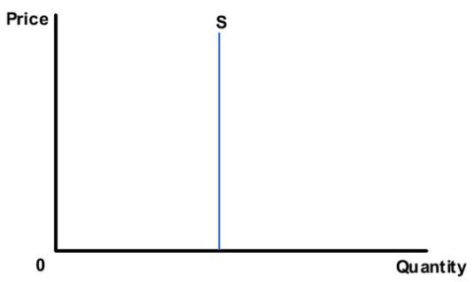

* PES = 0
* Meaning that price has no effect on supply at all.
* A change in price will mean that supply remains exactly the same

(Vertical supply curve)

1. **Inelastic supply**

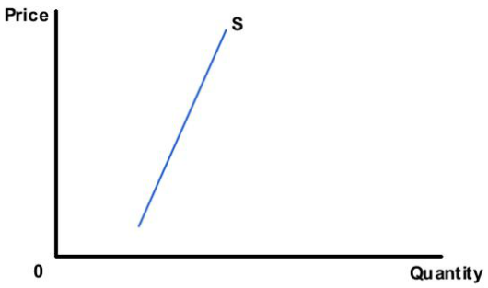

* 0 <PES <1
* Meaning % change in price is larger than the % change in supply
* Any change in price will result in a relatively smaller change in quantity supplied

(Relatively steep supply curve)

1. **Unit elastic supply**

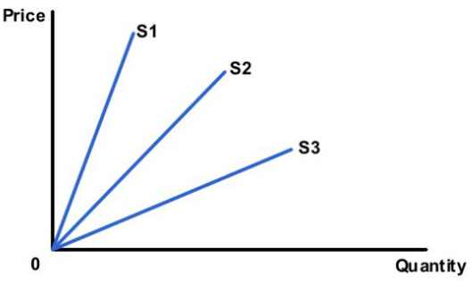

* PES = 1
* Meaning % change in price is identical to the % change in quantity supplied. (proportional)
* Any straight line supply curve that passes through the origin will have a PES value of 1.

(Straight line supply curve)

* Different from Unit elasticity demand curve

1. **Elastic supply**

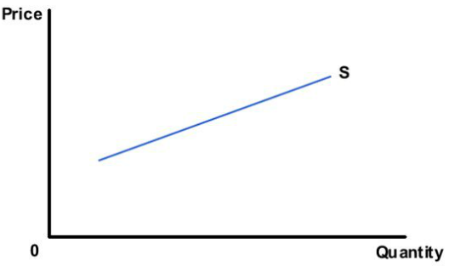

* 1< PES <∞
* Meaning % change in price is less than the % change in supply
* Any change in price will result in a larger change in quantity supplied

(Relatively flat supply curve)

* **Very responsive to price change**

1. **Perfectly elastic supply**

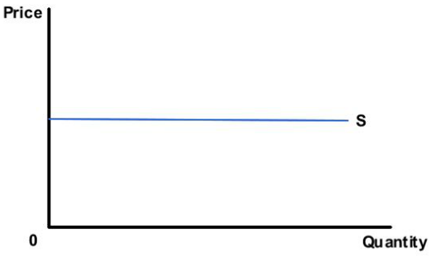

* PES = ∞
* Meaning an infinite amount is supplied at one price but nothing at all at a slightly higher price
* There is an infinite demand at one price level, but any other price levels, nothing will be supplied

(Horizontal supply curve)

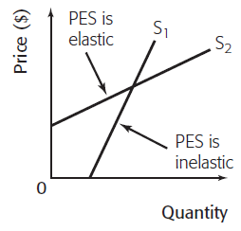

**IB Question**

***Determinants of PES***

* The value of price elasticity of supply for a good depends on a number of factors.

1. Time period considered

* In the immediate time period firms cannot immediately increase the number of factors of production that they employ
* In the short run, firms may be able to increase the quantity of some of the factors that they employ but may not able to increase all of the factors.
* In the long run firms may be able to increase the quantity of all the factors that they employ

2. Mobility of factors of production

If the factors of production are mobile or flexible, PES will be relatively elastic.

e.g.) It is easy to shift production from manufacturing one liter plastic bottle to manufacturing two liter plastic bottles because they are made from similar materials requiring similar production process.

3. Unused capacity

Unused capacity?

Output?

An amount manufactured or produced during a certain time.

If a firm has a lot of unused capacity (spare capacity), then it will be able to increase output easily and without great cost increases.

* High elasticity of supply

If a firm is producing at capacity (running at full capacity supply) then it is difficult to increase supply without a significant increase in productive resources which will be expensive. It is therefore unlikely that the firm will increase supply.

* Relatively Inelastic supply

4. Ability to store stocks

If a firm is able to store high levels of stock (inventories) of their product, then they will be able to react to price increases with swift supply increases and so the PES for the product will be relatively elastic. However, where it is impossible or expensive to hold stocks, supply will be inelastic. Some perishable goods will be inelastic because they cannot be stored for a long time.

25. Applications of price elasticity of supply

* Primary commodities have relatively low PES values (inelastic), while manufactured goods will tend to have higher values (more elastic).

We can see the reason from the table below:

|  |  |  |
| --- | --- | --- |
| Determinants | Wheat (p.c.) | Laptop (m.g.) |
| The time period | Relatively little opportunity to change supply - once planted, supply is effectively determined for a year | Supply is quite flexible - increased globalization means increased production capacity can be brought on relatively quickly |
| Substitutability | Very difficult to substitute factors of production | Factors of production relatively easy to substitute |
| Capacity factors | Once fields have been planted for a season, capacity is effectively fixed. Only in the long-run can it be changed significantly. | New capacity can be brought in relatively easily - particularly ina ore global economy |
| Stocks | Relatively perishable and so difficult to hold stocks for any significant period of time | Stocks can be held, though these may date as specifications improve |

A table showing a comparison of two products - wheat and laptops - against each of these determinants